N
E

Filmetrics F40 Operation
Standard Operating Procedure

- scope:
The purpose of this document is to provide operating procedures for Filmetrics F40 thin film measurement system.

- Equipment description:
Filmetrics F40 compares the reflectance spectrum of a measured thin film to a theoretically computed model of a material in order to obtain thickness information of the Transparent measured film, including oxide, nitride, photoresist, polysilicon,,, etc. The system does not require a reservation to operate.

- Film thickness measurement procedure:
  - Turn on the microscope light by turning the intensity adjuster at left bottom of the microscope stand to where the indicator on knob is pointing up.
  - Logon to computer as user “public”.
  - Start the application software by double clicking the “film measure” icon on top left corner of the computer screen as shown in Fig.1. A film measurement page will open as seen in Fig.2
Figure. 1 application icon

  - Select the recipe by clicking the down arrow button above the Edit Recipe button at right lower side of the measurement screen and choose the proper recipe from the drop down menu by clicking on the recipe. See Fig.3
  - Click the “Edit Recipe” button to open up the recipe page and check to make sure film stack information is correct as shown in Fig. 4 and enter the best guess of the film thickness into the thickness field.

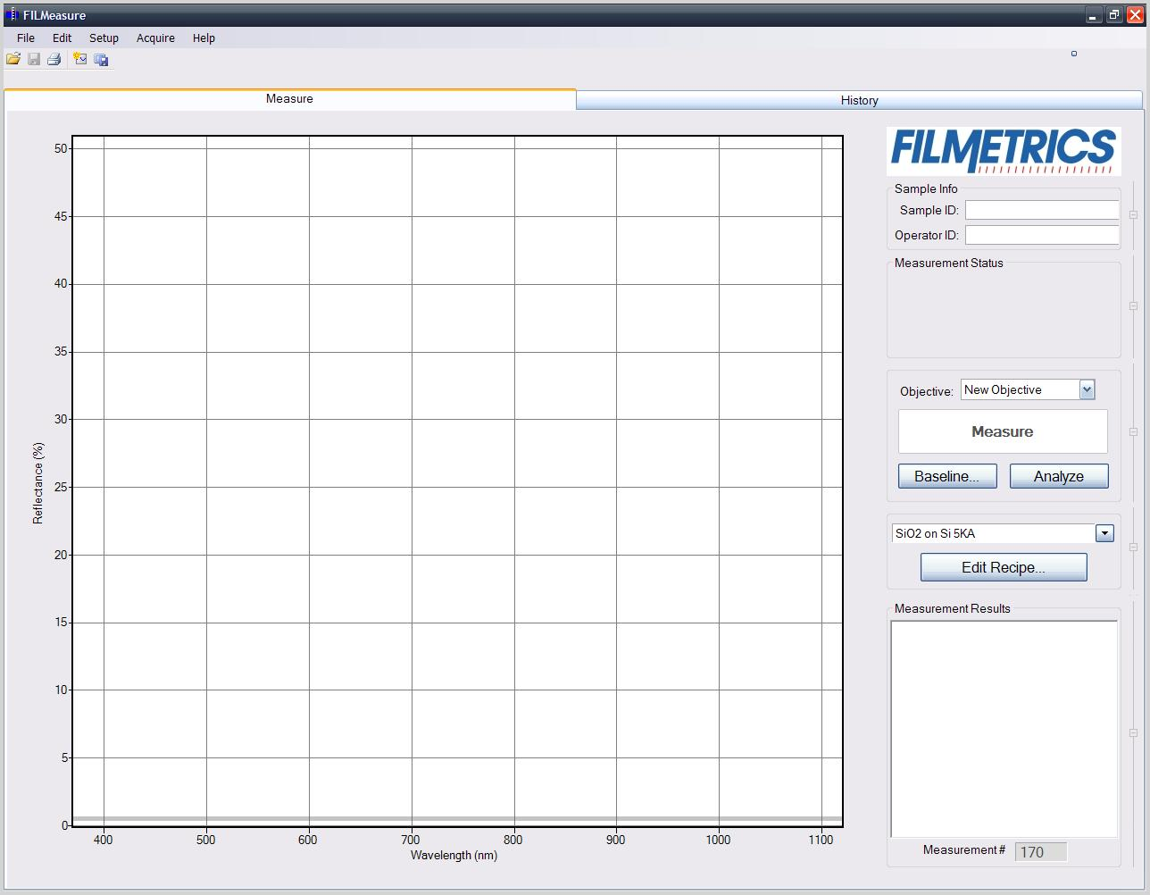
Figure 2 measurement screen

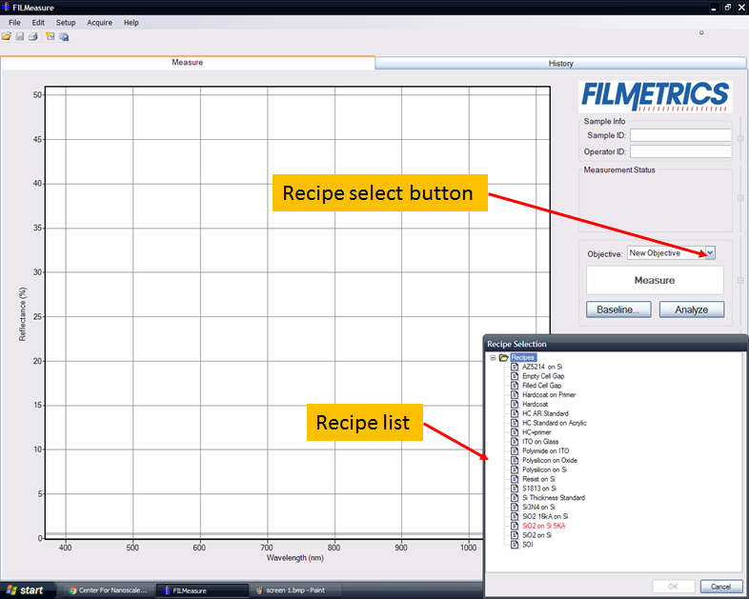
Fig. 3 Recipe screen

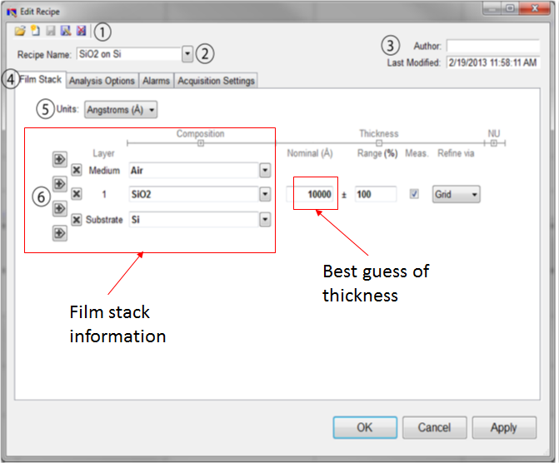
Figure 4

  - Place samples to be measured under the optical microscope 5X objective. The spot size for using 5X objective is about 100 microns. Focus on the spot where measurement will take place. Use “field stop” function on the microscope to assist focusing on blanket films if needed.

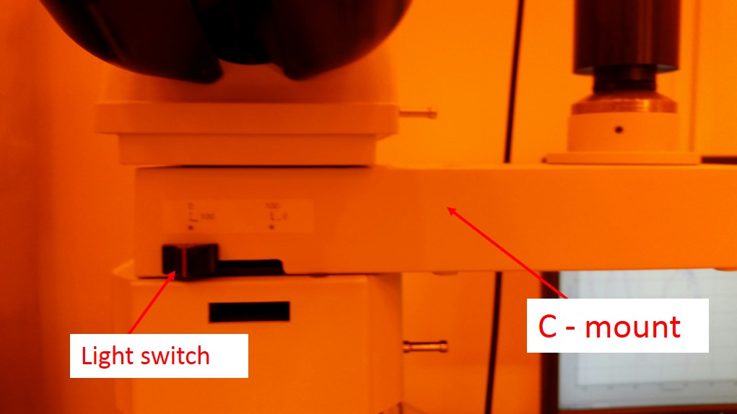
Fig. 5 light switch
  - Slide the light source switch on the c-mount to the left to allow light go through the c-mount and into the filmetrics optics. See Fig.5
  - Click “baseline button and follow the instruction from the pop up window to take all three baseline reflectance including,” for sample to be measured”, “Si standard” and “Dark” which is no sample under the microscope.
  - After all three baselines have been taken successfully, the measure button on the middle of the right hand side of measurement screen will turn light blue and system is ready to take measurements.
  - Place sample back onto the microscope stage and take measurements by clicking the measurement button.
  - The result will be shown on the right hand side of the screen as shown in Fig.6. Also a GOF number will be shown. A GOF number between 0.8 to 1 is considered a good fit. Left side of the screen are two spectrums. The red spectrum is calculated based on model and the blue one is the reflectance spectrum form the actual measurement. A GOF number is based on the similarity comparison between the two spectrums.

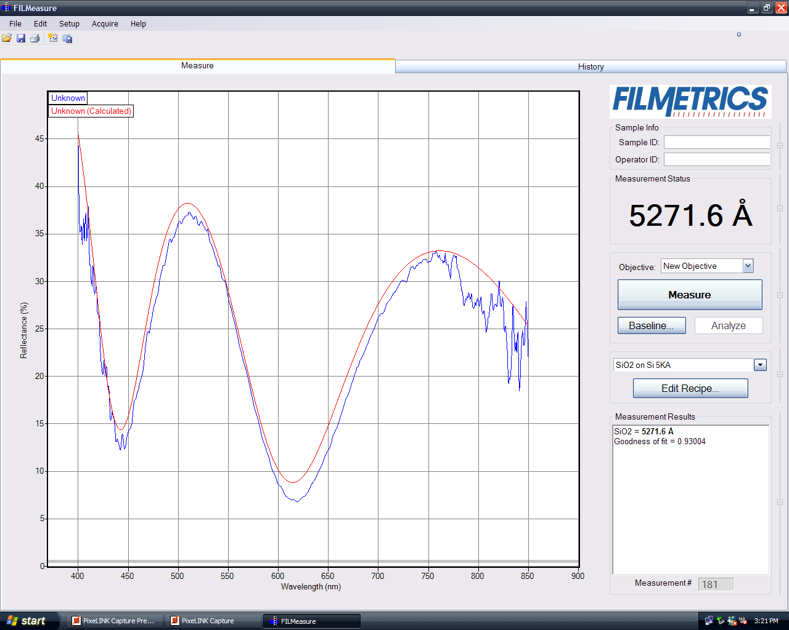
Figure 6 measurement spectrum and result

- Recipe Edit:
  - Click the “Edit Recipe” button will open up the recipe content page as shown in Fig.7
  - You can edit the film stack by clicking the “+” or “-“sign to insert or delete a layer form the film stack.
  - To insert a layer. Click the “+” in between where the layer should be. Click the down arrow at the right side of the newly inserted material and choose the material from the drop down menu as shown in Fig.7. Contact and consult with stuff for creating new material not listed in the library.
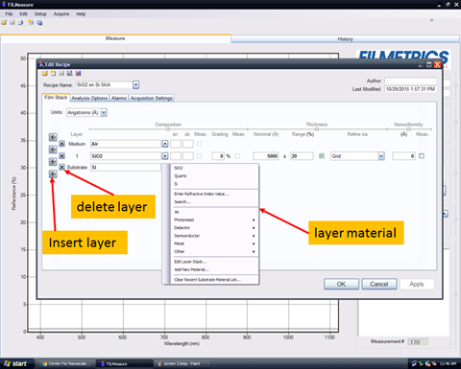
Fig. 7 recipe editing page

- New Recipe Creation:
  - Buttons on the left upper corner of the edit film page as shown in Fig.8 are, from left to right:
- Open a saved recipe.
- Start a new recipe.
- Save the current settings.
- Save the current settings as new recipe.
- Delete the current recipe.
  - A new recipe can be created by click the “start a new recipe” button and film stack can be created / modified by using the same method as editing a recipe described in 4.2.
  - Save the new recipe using “save the current settings as a new recipe” button and give a new name.
  - Do not use “save the current settings” after you opened an existing recipe file and modified any portion of the recipe.

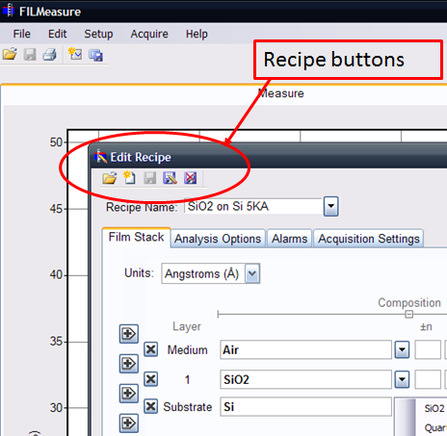
Figure 8 Recipe buttons

- Shut Down:
  - Remove sample from microscope.
  - Slide light switch on c-mount back to the right.
  - Lower microscope stage and turn off the microscope light.
  - Close measurement window by clicking X on top right hand corner of the screen.

