N
E

E-BEAM LITHOGRAPHY SYSTEM
OPERATING PROCEDURE

Equipment needed:

- Resist Spinner
- PMMA - Suppliers of e-beam resist are listed on the "Other Resources" page of the NPGS web site. http://www.jcnabity.com/ When using PMMA, the 950k molecular weight PMMA will give the highest lithography resolution. The concentration of the PMMA purchased will determine the range of thicknesses that can be obtained by varying the spin speed. To lower costs and increase flexibility, one option is to purchase a relatively concentrated supply of PMMA and subsequently make other concentrations by diluting a portion of the concentrated PMMA with the appropriate solvent.
- Substrates
- Acetone
- Ultrasonic cleaner
- Oven - When using PMMA, the sample should be baked at 160C for >2 hours after it is spun onto the sample. Alternately, a hot plate can also be used to bake the sample after coating with PMMA.
- Stop Watch
- Developer, 3:1 IPA:MIBK - 3 parts isopropyl alcohol to 1 part methyl isobutyl ketone, or more precisely: 3 parts (2 propanol) to 1 part (2-pentanone,4-methyl). The developer should be mixed under a hood before the NPGS training. Typically, 30 to 50 ml will be used during the training, but more can be mixed and used for months.
- Fume Hood
- 2 Beakers - Typically 50 ml to 100 ml. The beakers should be cleaned.
- Compressed N₂ - To blow off the sample. Alternately, almost any compressed gas can be used.
- Optical microscope - Used to inspect the sample after development. While an optical scope isn't absolutely required, it is highly recommended. Typically, the best quality optical scope that can conveniently be accessed will be used.
- Sputtering System - The sample must be coated before viewing in the SEM, however, an evaporation system may be used instead. Metals with a small grain size such as AuPd, Ti, or Cr, are highly recommended, but other metals such as Au can be used, if necessary. The facilities for coating the sample should be evaluated before the training visit to ensure that they will be readily available on the third day of the training and can reliably produce a film with a thickness of about 20 nm.
- Evaporator - If a sputtering system is not available, an evaporator can be used.

- SAMPLE PREPARATION:

- A layer of e-beam resist needs to be spin coated onto a substrate in order to do e-beam lithography using the Zeiss (Leo) Supra 55. The resist can be chosen according to users’ purposes. Here we take PMMA 950 A-2 as an example.

- Set the substrate in the spin coater on an appropriate vacuum chuck. Spin it and squirt it with acetone then wash off acetone with excess IPA.
- Let it spin and dry with little nitrogen flush.
- Put 3-4 drops of PMMA on center and let it spread out on the chip for 3-4 seconds.
- Switch on the spinning. First spin @ 400 rpm for 3 seconds and then spin @ 4000 rpm for 30 seconds.
[Note: Photo resist are carcinogenic so any sort of contact (physical/air borne) should be avoided.]
- Once the spin coater stops, transfer the sample to a hot plate heated to 180 ºC.
- The spin coated chip is pre-baked for 70-90 seconds just to evaporate the solvent in the photo resist and make the coating a little hard.

- After the e-beam resist is coated onto the substrate, a scratch needs to be made at one corner of the substrate as shown below.

This scratch will later be used as a reference for secondary focusing and the start point of your pattern.

- Put the e-beam resist coated substrate onto a sample holder with clips and gold standard on it. The substrate should be placed in the manner as shown below. The corner with scratch is closer to the gold standard and the edge of the substrate should be as parallel to the gold standard as possible. Now, the sample is ready to go.

- INITIAL COMPUTER INTERFCAE:
  - Login by clicking the icon “SEM user interface”.
  - After login look for the toolbar. Take the toolbar on the right screen.
  - Press CTRL-D for data bar. (It will come at the bottom of computer screen)
  - In data bar look for EHT (Extra High Tension) value. It should be 10 KV.
  - Press CTRL-G for SEM control.
  - Look for aperture value. It should be 30 microns for SEM and 7.5 microns for E-beam.

- STARTING STATUS OF SEM:
  - After putting the sample inside the following check must be done. Look for the following starting status of the SEM.

Lights/Switch | Labels
Pump | Wait
Open | Proceed
Close | Rod Status
Purge | Gate

The status of different buttons at starting will be as follows:

Pump-Off | Wait-Red
Open-Off | Proceed-No Light
Close-On | Rod Status- On/ no blinking
Purge-Off | Gate- Off
(If the rod status is blinking, it means rod is not totally out. Bring out the rod by gently pulling it until the rod status LED stops blinking.)

- LOADING THE SAMPLE INSIDE THE SEM CHAMBER:
  - Purge with Nitrogen then open the outer chamber door.
  - After checking the starting status of SEM and finding it correct, go through the protocol indicated below strictly.
  - Press the ‘PUMP’ button to initiate the pumping of the airlock.
2 a) If pump is not working: This means that chamber valve for the gun chamber of SEM is not closed. Follow these steps on computer screen to close it.
Go to Tools
Goto Panel
SEM control window
Airlock

Close Chamber Valve

Press pump on Air lock

  - Wait till ‘WAIT’ light is on and proceed to the next step only when ‘PROCEED’ light turns to green.
  - Select the ‘OPEN’ button and deselect the ‘CLOSE’ button. As soon as you do this you will see that the ‘GATE CLOSED’ LED stops glowing. Then in a couple of seconds the ‘airlock chamber door’ will open.
  - After this put the sample with rod inside the sample chamber. (While doing it, lift the rod a little bit, as rod sacks in the middle because of its weight)
  - After properly putting the sample in the ‘sample chamber’, unscrew the rod and take it out.
  - Close the door by pressing the close button and deselecting open.
  - Purge again so that the pressure across the gate becomes equal.
  - Open the chamber valve. (Again follow the procedure described in 2a).

- ALIGNING THE SAMPLE:
Please follow the following procedure on the computer screen:

Go to stage

Go to
‘Store /recall’

Click
‘$ Center’

Align it properly by UV camera controls

Switch on the EHT

(There distance in Z- direction between the gun and the sample should be more than 47 mm.)

- IMAGING:
- Before switching to NPGS (Nanometer Pattern Generation System) program, we need to adjust focus, astigmatism, and aperture alignment by imaging gold standard under SEM mode. If you are able to see the facets of the gold grains at 200kX, it means the adjustments are good for EBL.

  - Click ‘Chamber Scope’ on computer screen. This is a kind of toggle switch which toggles the picture on computer screen from UV Camera mode to Sample image.
  - There are many buttons for fine tuning. The following table lists them and their functions.

Button | Function
Brightness/Contrast | Helps in fixing brightness and contrast
Magnifying/Focus | Helps in magnifying and focusing on the sample
Reduced Roster | Helps in working only in small area of sample. After adjusting the different parameters, the whole image will be changed according to the new parameters
Stigmitation | Helps in fine tuning the picture

(The sample can be adjusted in ‘X-Y’ plane but avoid adjusting in Z- direction)

- TAKING PICTURE:
  - After securing a good image according to the requirements, go to scanning button on computer screen.
  - Select scan speed. Higher the speed, better the resolution but also higher the time.
  - Freeze the image.
  - Send to TIFF type of file.
  - Give a file name.
(If the point to point measurement is required, click CTRL-A and go to annotation toolbar)

- SECONDARY FOCUSING
  - After the first focusing on gold standard, move the stage so that the corner with scratch is at the center of the screen.
  - Use joystick to find the end of the scratch on the substrate.
  - After locating the end of the substrate, focus on the debris generated from the scratch by moving Z axis down.
  - Once you have the best focus, go to NPGS program and click on “NPGS mode”.

- Nanometer Pattern Generation System
- There are two parts in NPGS. First, DesignCAD software is used to generate pattern design. It is like other CAD software, such as AutoCAD, but with simpler layout. For the details of using DesignCAD, please refer to its manuel. Second part is Run file. Run file is used to control the stage movement, pattern input, and electron dosage, etc. The following procedure will guide you how to create a Run file.

  - set working distance to 6cm in NPGS software by clicking “set WD=6”
  - switch on beam blanker
  - click on the “Run File Editor” in the NPGS window

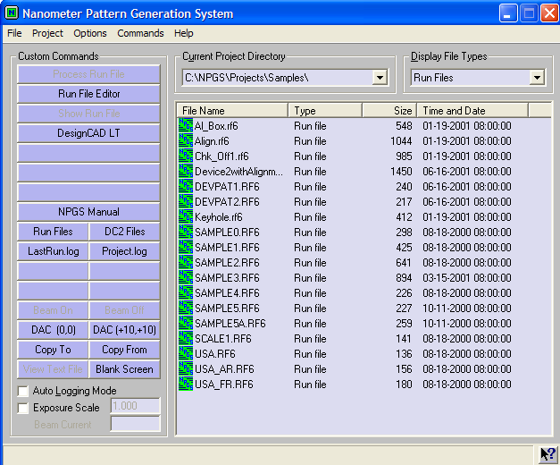

  - Run file Editor window will popup after click on “Run File Editor” button. You can add more entries by selecting “Number of entities to process”. Normally, 3 entities will be needed, “move only” →”pattern”→”move only”.

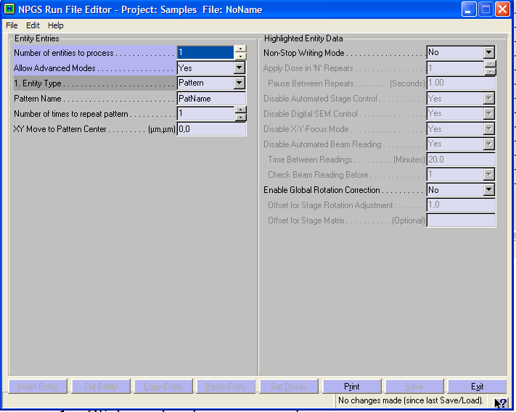

  - Under the “pattern” entity, you can adjust the magnification, center-to-center distance, line spacing, beam current, and dosage.

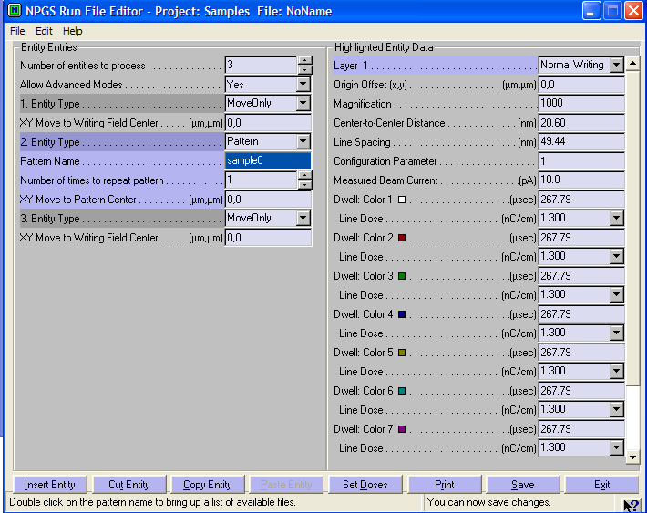

  - After finishing editing run file, click on “save” at the lower right corner. Then, click on “Process Run File” in the main window. And wait until the process is finished.

- CLOSING:
- After NPGS finishes all processes, go back to SEM and follow the steps below to close the system and take out your sample.

  - Click on chamber scope mode.
  - Turn off EHT.
  - Go to ‘Stage’ then to ‘Store/Recall’ then to ‘$ exchange’.
  - Close ‘chamber valve’.
  - Start ‘Pump’ to make the pressure difference zero between the outer chamber and sample chamber.
  - When ‘proceed’ light goes green, open the gate.
  - Take out the sample with the help of rod.
  - After taking out the sample, leave the SEM in exact position as its ‘starting status’

- DEVELOPING E-BEAM PATTERN (PMMA)
- Again, resist development will depend on the type of resist you use. Here, we use PMMA as an example.

- Dip the chip in MIBK solution (MIBK : isopropanol = 1 : 3) for 90-100 seconds and shake.
- Dip and shake the chip in isopropanol for 20 seconds.
- Wash the sample with DI water for 20 seconds.
- Dry out the sample with N₂.

- METAL DEPOSITION AND LIFT OFF

- deposit metal on developed substrate using sputtering for 60 second.
- after metal deposition, dip the chip into acetone for ~10 minutes (sonicate if need high resolution)
- wash with IPA and DI water and your EBL is done!

