N
E

5214E IMAGE REVERSAL RESIST

What image reversal means...
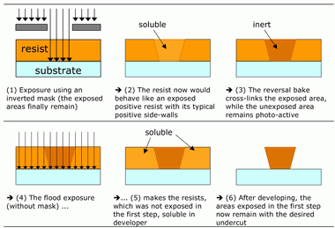
...and for what it is good for:
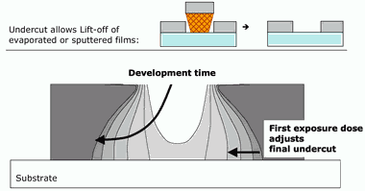
AZ 5214E
AZ® 5214 E is a very special photoresist which is capable of image reversal. Exposed areas may be selectively cross-linked by applying a bake cycle after exposure. A flood exposure before development converts unexposed areas soluble, resulting in a negative tone image. The profile generated by such processing has a negative shape (wall profile) allowing for use in lift-off techniques. AZ® 5214 E is the only available viscosity

