N
E

Cambridge Nanotech Savannah 100
Atomic Layer Deposition System (ALDS)

1.0 SCOPE
This document establishes the procedures for operating the ALDS system inside the cleanroom. There is no additional charge to use this tool. Online reservations are mandatory.

2.0 APPLICABLE DOCUMENTS
ALD System logbook

3.0 MATERIALS AND EQUIPMENT
ALD System
Tweezers
UV Ozone Cleaner
Acid cleaning bench (Personal safety equipment)
Nitrile Gloves
Cleanroom wipes

4.0 GENERAL
4.1 The Cambridge NanoTech Atomic Layer Deposition (ALD) system is capable of providing many coating applications. ALD is used to deposit thin films with exceptional qualities. A large number of standard materials are available.
4.2 The principle of ALD is based on sequential pulsing of special precursor and water vapors, both of which form about one atomic layer each pulse. This generates pinhole free coatings that are perfectly uniform in thickness, even deep inside pores, trenches and cavities.

4.3 Vacuum Integrity Maintenance. Maintaining a low background pressure is necessary to deposit quality thin films. To avoid contamination these practices are to be followed:

4.3.1. Never touch any part(s) inside the reactor or part(s) going into the
reactor with bare hands or contaminated gloves.

4.3.2 Handle parts going into the reactor with
gloves and/or clean metal tweezers.

4.3.3 Never touch the reactor metal inside or outside directly, it is kept hot at all times!

4.3.4 Clean any area or tool that will contact reactor chamber parts by
wiping with lint-free wipes and isopropyl alcohol.

4.3.5 Do not use any material in the reactor that has not been approved by the cleanroom staff. This includes tape, plastic, or
any custom wafer holders.

4.3.6 The reactor chamber should not be subjected to atmosphere for excessive periods; pre-deposition preparation should be done in a timely manner to avoid such exposure.

4.3.7 A cleanroom mask must be worn while the chamber is open.

4.3.8 Load only clean substrates into the reactor chamber.

4.3.9 Emergency Shut Off: The emergency power switch is located inside the cabinet to the left and just below the chamber. (Figure 1) This will shut down the whole system and should only be used in an emergency situation.

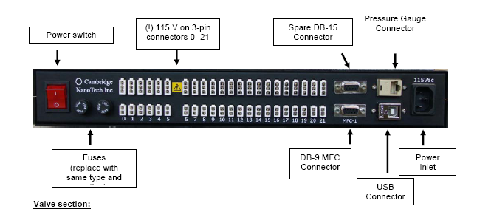

Figure 1

4.4 Precursors
4.4.0 There are 3 precursor gases available in our system:

Trimethylaluminum for depositing Aluminum oxide (System gas #1)

Tetrakis(diethylamido)zirconium(IV) for depositing Zirconium oxide (System gas #2)

Tetrakis(diethylamido)hafnium(IV) for depositing Hafnium oxide (System gas #3)

DI water vapor (System gas #0) is pulsed in between each precursor gas pulse to form a passivation layer with the precursor gas.

The three precursors above are provided by the NanoFab. Other precursors are available commercially at:

http://www.cambridgenanotech.com/papers/al_chemfile_v4_no3.pdf

Check with the lab manager before purchasing new precursors.

5.0 System Preparation

The ALD system is designed to run in “ready” mode at all times. The surface of the reactor will be heated to 250 deg. C. and there will be 20 sccm nitrogen flow. Never turn off the PC that operates the system or close the application program!

Danger: Always keep the safety shield over the reactor when not loading to prevent burns.

5.1 Click on the “Process” tab (Figure 2) to verify that system is in “ready” mode:
Stop Valve is open
Flow is 20 Sccm
Reactor and inlet temps are 250 deg. C.
Gauge pressure is approx. 2.00E-1 or lower

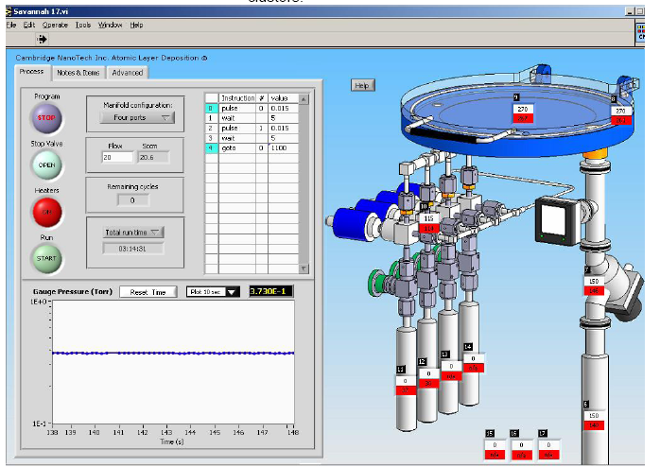

Figure 2

5.2 Right click on the recipe step list and select “Load Recipe”

5.3 Select desired recipe:
Aluminum Oxide
Zirconium Oxide
Hafnium Oxide
And click “OK”

Never click “Save Recipe” This will over-write the standard programs!

5.4 Verify recipe has loaded for the correct material:

5.4.1 There are 2 pulse steps in each recipe; the first is always for DI water and the second is the precursor gas. Note the number in the # column next to the second pulse step. It should match the ID number of the material you are depositing:

#1= Aluminum
#2= Zirconium
#3= Hafnium

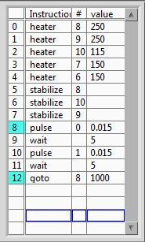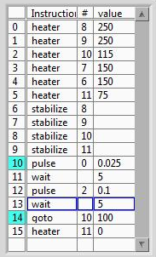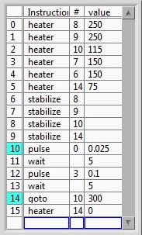
Aluminum Zirconium Hafnium

5.4.2 In the “Value” column, click on the “Go To” line and set the number of cycles desired. The current recipe for Aluminum oxide yields approx. .95 angstroms per cycle. (500 cycles grows a 476 angstrom layer)

You are ready to prepare your wafer!

6.0 Sample Preparation

6.1 It is recommended that silicon wafers be pre-etched in room temperature BOE etch to remove any oxide layers just prior to ALD processing. Wafers of different materials will require alternative cleaning procedures. Consult with lab staff for proper cleaning processes.

Warning: BOE Etch contains Hydroflouric Acid. Read safety manual on handling Hydroflouric acid prior to using!

Wafers should be placed into the Ultra Violet Ozone Cleaning system immediately prior to loading into reactor. This process will remove all organics and ensure the sample remains hydrophilic just prior to loading.

6.1.0 Turn on U/V Ozone cleaner and set timer for 30 minutes then start. This will prepare cleaning system for usage.

6.1.1 Prepare Acid bench by turning on cascade water flow to high and turn on cascade bubbler.

6.1.2 Mount wafer into Teflon carrier and put on acid safety gear:
Acid Apron
Acid gloves over nitrile gloves
Face Shield

6.1.3 Set bench timer for 1 minute and dip wafer into BOE tank, agitating slowly until timer alarms.

6.1.4 Remove wafer directly into cascade bubbler rinse and leave for 5 minutes.

6.1.5 Transfer wafer to cascade final rinse side and leave for 5 more minutes.

6.1.6 Remove wafer to lint free cloths on top of bench and blow dry with nitrogen.

6.2.0 Using clean wafer tweezers, place wafer into U/V Ozone cleaner and set timer for 10 minutes. (Do not look directly at U/V cleaner when opening door)

6.2.1 When timer sounds, Remove wafer immediately and load into the ALD reactor chamber.

7.0 Operation:

7.1 Check log book to see if last user reported any problems. Contact staff if problem resolution has not been logged.

7.2 Wafer should be in U/V ozone cleaner for at least 5 minutes prior to venting reactor.

8.0 Loading:

8.1 Click on Stop Valve to close it and the system will begin to vent

8.2 Highlight “Flow” and increase to 100 Sccm. (Figure 3)

8.3 Remove heat shield from on top of reactor cover. (Figure 4)

8.3.1 After approx. 2 minutes, reactor chamber is ready to open.

8.4 Remove wafer from U/V Ozone cleaner with tweezers and bring to ALD system.

8.5 Lift reactor cover being careful to only touch the insulated handle.

8.6 Place wafer in center of reactor well and close cover.

8.7. Click on Stop valve to begin pumping system down.

8.9 Highlight “Flow” and decrease to 20 Sccm.

8.10 Re-install heat shield on top of reactor.

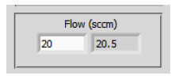
Figure 3

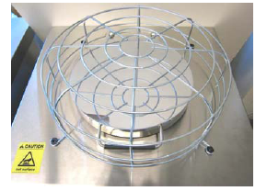
Figure 4

9.0 Start Run

9.1 Wait 10 minutes for wafer temperature to stabilize and system to pump out.

9.2 When system reaches 4.00E-1 on pressure gauge, click on start button.

9.1.1 System will verify all heaters are at proper setpoint then begin cycling.

9.1.2 During each cycle, the system pressure will momentarily increase each time the precursor or DI water pulses. (Figure 5)

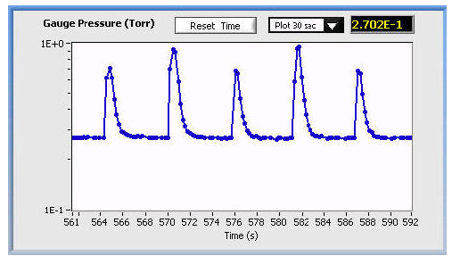
Figure 5

9.1.3 Remaining number of cycles and run time are displayed during run. Be sure to be present at the machine when cycles are complete.

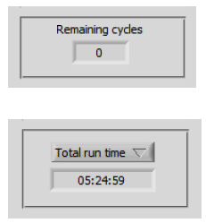

10.0 Unloading

10.1 To vent reactor chamber repeat steps 8.1 thru 8.3.1

10.2 Wafer will be hot so use tweezers and be careful not to touch reactor chamber with gloves.

10.3 Blow nitrogen on wafer for 30 sec. to 1 minute to cool

10.4 To re-pump system and place in “ready” mode repeat steps 8.7 thru 8.10.

10.5 Fill out log book and note number of cycles run.

10.6 Check film thickness with ellipsometer or filmetrics.

