N
E

EMS 1050X Plasma Asher
Operation Procedure

1.0 SCOPE
This document establishes the procedures for operating the EMS Plasma Asher system inside the cleanroom. There is no additional charge to use this tool. Online reservations are not mandatory.

2.0 APPLICABLE DOCUMENTS
Plasma Asher system logbook

3.0 MATERIALS AND EQUIPMENT
Plasma Asher System
Tweezers
4” support wafer
Nitrile Gloves

4.0 GENERAL
4.1 The EMS 1050X Plasma asher is a small reactor that consists of a solid state RF generator and associated tuning circuits, a vacuum system with solenoid valves, a constant feed gas supply system and a reaction chamber which includes two semicircular electrodes and a two piece Pyrex chamber. The unit capable of controlling two process gases and is currently configured with pure Oxygen only, connected Gas control #1.
4.2 The plasma process is accomplished through the use of low pressure, RF induced gaseous discharge. The specimen is loaded into the reaction chamber, the chamber is evacuated, a carrier gas (Oxygen) is introduced into the chamber raising the pressure to 5x10-¹ to 1x10 ⁰ mbar, depending on the application. RF power is applied around the chamber at 13.56MHz. This excites the carrier gas molecules and dissociates it into chemically active atoms and molecules. This ionization process occurs at relatively low temperatures without employing toxic chemicals and is excellent at removing (ashing) organic materials.

4.3 Vacuum Integrity Maintenance. Maintaining a low background pressure is necessary to provide rapid pumping and turn around. To avoid contamination these practices are to be followed:

4.3.1. Never touch any part(s) inside the reactor or part(s) going into the
reactor with bare hands or contaminated gloves.

4.3.2 Handle parts going into the reactor with
gloves and/or clean metal tweezers.

4.3.7 A cleanroom face mask must be worn while the chamber is open.

4.3.8 Load only substrates that have previously been cleaned with acetone or Pirahna etch into the reactor chamber. Do Not attempt to strip your entire layer of photo-resist with this tool!

4.3.9 Emergency Shut Off: The emergency off is located on the right hand side of the front panel and is labeled “Stop”. This will terminate all processes and vent the chamber to atmosphere. If the Stop button is pressed during a cycle Error message will be displayed.

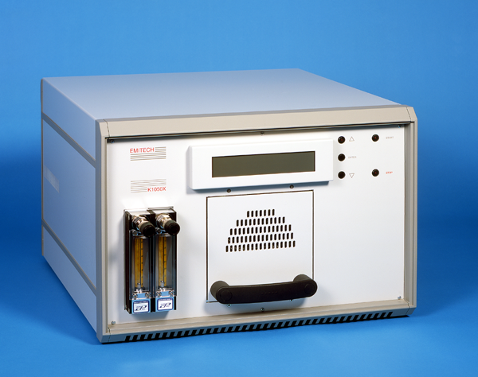

Figure 1

5.0 System Preparation

The 1050X Plasma Asher system is designed to run in “ready” mode at all times. The LCD panel will display a message that requires the user to either input the required working parameters or start a cycle using current settings.

5.1 Inspecting the chamber:

5.1.1 Slide open the door. Check the outer chamber. Make sure that there are no cracks in the chamber. Contact staff if any irregularity is noticed.

5.1.2 On the door section, make sure that the sealing gasket seals correctly against the inner lip of the chamber.

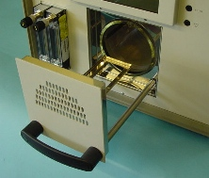

6.0 Sample Preparation

6.1 It is recommended that silicon wafers be pre-cleaned or stripped using acetone rinse and/or Sulfuric acid and Hydrogen peroxide (Pirahna) etching methods. Wafers of different materials will require alternative cleaning procedures. Consult with lab staff for proper cleaning processes.

7.0 Operation:

7.1 Check log book to see if last user reported any problems. Contact staff if problem resolution has not been logged.

7.2 Operation of this unit consists of loading the specimen to be processed, evacuating the chamber, applying the process gas and energizing the RF power. The RF power output and chamber impedance has to be matched for the best power transfer. The output power and reflected power are displayed on the LCD and during normal operation the reflected power will drop to approx. 0.

8.0 Loading:

8.1 Pull the loading tray out from the chamber. If your sample is a 4” wafer, place it on the loading tray in the center and slowly slide the tray into the chamber making sure the wafer does not contact the sides.

8.2 If your sample is smaller than a 4” wafer, you will need to place a 4” wafer on the tray first, following step 8.1 and then place your sample on top of the wafer.

9.0 Check Program Parameters:

At power up the system will show.

9.1 The user is prompted to input the required working parameters or start a cycle using current settings.

Press enter to load/change parameters
UP or DOWN arrow to use stored values
Press start to run when ready

If required press “ENTER” to change operating parameters. The display then shows:

UP or DOWN to alter
ENTER to accept, STOP to return
Parameter Name Current Value Units if any.

9.2 There are three stored setups that may be used:

Ashing Power and Times
NOTE: - Ashing power and times will vary considerably depending on application. Some broad guide lines are given.

Setup 1- Light Surface Etching. O₂ - 6 x 10⁻¹ - 50 Watts - 10 Mins.
Setup 2- Complete Ashing. O₂ - 6 x 10⁻¹ - 75 Watts - 30 Mins.
Setup 3- Complete Ashing. O₂ - 6 x 10⁻¹ - 100 Watts - 2/3 Hours

9.3 Select desired Setup 1,2 or 3 using “up” or “down” arrow keys and press “Enter”.

9.4 Press “Enter” again to check program working parameters are set to default values. Parameters are in the order:

RF Power Level, Ashing Time, Bleed delay time. Process Gas, Vent Valve, (Full/Restricted Purge), Pump Spin down time, Vent Hold time, Gas Shut of time, Turbo pump enabled.

9.5 Adjust “Ashing Time” if desired, by using up or down arrow keys and the enter key after each time increment is set; Hr. Min. Sec.

9.6 Verify the rest of the parameters are set to the default values shown in table below and that power levels are set per step 9.2. When the correct value is reached press “ENTER” to accept and proceed to the next parameter. If no other parameter is to be edited press “STOP” to exit to the Main Start-Up Menu.

9.7 When the prompt to save the amended parameters is shown it offers to store the parameters in SETUP 1 Press “ENTER” to store modifications to setup 1 or use the up or down arrows to navigate to the desired setup number in the range 1 to 3. Reminder, Store only default values and desired “Ashing Time” into current setup number.

PARAMETER | PARAMETER TYPE | UNITS | DEFAULT VALUE | MIN. VALUE | MAX. VALUE | INCREMENT VALUE
RF Power Level | Setup | Watts | 100 | 10 | 100 | 5
Ashing Time | Setup | Hrs/Mins/Secs | 0:30:0 | 0 | 99:59:59 | Hrs/Mins/Secs
Bleed Delay time | Setup | Secs x 10 | 3 | 0 | 255 | 1 (10 secs)
Process Gas | Setup |  | Gas 1 |  | Gas 1  Gas 2  Both Valves | Needle Valve Variable.
Vent Valve  (full or restricted purge) | Setup |  | Restricted |  | Restricted  UN-Restricted  Both Valves
Restricted Vent Time | Global | Secs | 120 | 60 | 255 | 1
Pump Spindown time | Global | Secs | 10 | 10 | 240 | 1
Vent Hold time | Global | Mins | 0 | 0 | 60 | 1
Gas shut off time | Global | Secs | 5 | 1 | 240 | 1
Turbo pump enabled | Global | 0 | 0 | 1 | 1 | 1

10.0 Running Process:

To start a cycle the user presses START and the Instrument will run through the cycle and vent at the end. The venting cycle is set to 120 seconds and the tray will not pull open until this time has elapsed.

When the R.F. initially turns on it starts at default power to strike the plasma and the internal control loop will then bring this to the set level. Reflected power should drop to 0.

11.0 Terminating a process:

If the user wishes to terminate the process at any time they just press “STOP” and the cycle will stop and the chamber will be vented to atmosphere. (An “ERROR” message will be displayed when stopped during a cycle.)

11.1 If during the Ashing part cycle it is required to increase or decrease the R.F. Power Level this can be achieved by pressing the “UP” or “DOWN” arrow keys.
The Ashing power level will be updated on the display and the internal control will slowly reach the new target value.

12.0 Unloading Sample:

Unload sample using tweezers and gloved hands. Do not touch processed sample to prevent contamination or potential burns from long runs.

12.1 After removing the processed sample, the unit is ready for the next user.
The system is designed to be left on and ready at all times.

12.2 If any error messages occur, contact staff immediately and note in log book.

12.3 Completely fill out and sign the log book.

9.3
Figure 5

9.1.3 Remaining number of cycles and run time are displayed during run. Be sure to be present at the machine when cycles are complete.

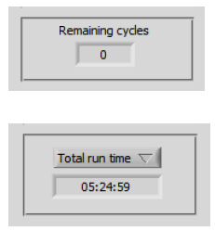

10.0 Unloading

10.1 To vent reactor chamber repeat steps 8.1 thru 8.3.1

10.2 Wafer will be hot so use tweezers and be careful not to touch reactor chamber with gloves.

10.3 Blow nitrogen on wafer for 30 sec. to 1 minute to cool

10.4 To re-pump system and place in “ready” mode repeat steps 8.7 thru 8.10.

10.5 Fill out log book and note number of cycles run.

10.6 Check film thickness with ellipsometer or filmetrics.

