N
E

ELLIPSOMETER OPERATIONAL
PROCEDURE

The ellipsometer tool is a Jobin Yvon Uvisel model M200 spectroscopic Ex-situ, phase modulated bench top unit with a spectral range of 240-850nm.

The Light Source
- Fully stabilized 75W Xenon arc source
- Spectral range: 180-2200nm
- Life time: 1500hrs.
- Automated micro-shutter

Optical Fibers
- UV and NIR grade optical fiber
- Fiber length: 3m

Excitation and Detection heads
- The excitation head is a polarizer coupled to a photo-elastic modulator

- The Polarizer:
- Calcite Glan polarizer mounted in rotating plate
- Accuracy in orientation better than 0.05 deg.
- Extinction coefficient better than 10⁻5

- The Photo-elastic modulator:

- Formed by a base of fused silica with two piezo-electric crystal contacts
- The resonance frequency is 50 khz
- The temperature of the modulator is stabilized @30+/- 0.1 deg. C

- The detection head is an analyzer identical to the polarizer of the excitation head

Goniometer
- The two heads are mounted on a goniometer for ex-situ applications
- The goniometer allows the user to manually select angles between 50 and 70 degrees in 5-degree increments

Sample stage
- The sample stage is integrated to the goniometer
- The stage is manual and horizontally adjustable to allow sample height adjustment
- An autocollimator also integrated into the goniometer allows adjustment and control of the sample stage tilt
- The stage is equipped with a vacuum sample holder

Micro-Spot
The micro spot feature allows selection of three different beam diameters
- 1 mm (standard)
- 0.1 mm
- 0.05 mm

Monochromator
- M200 monochromator
- Focal length: 200 mm, F/3.5
- Grating: 1200gr/mm
- Spectral range 190nm – 850nm
- Resolution: 0.5nm @ 500nm
- Dispersion: 4nm/mm @ 500nm

Detector:
Two types of detector are used depending on spectral range:
- PMT detector for UV-visible applications
- IR detector for Infrared extension up to 1700nm

Electronics rack:
- 1 Acquisition module (ACQDSP)
- 1 HV module which generates a programmable high voltage for the PMT
- 1 PIO module
- 3 Mmotor drives (MDR) module for control of monochromator, analyzer and modulator position
- 1 Power supply

Software:
- Provides control of modulator, analyzer, goniometer, monochromator, etc.
- Automatic calibration routines
- Spectroscopic and kinetic data acquisition
- Variable Angle (of incidence) Spectroscopic Ellipsometry (VASE)
- Single and multi-layer modeling for thickness, roughness, dielectric function, and composition determination

USING THE ELLIPSOMETER

Using the ellipsometer consists first of data measurement and then model fitting.

Data Measurement
- Turn on the xenon arc lamp (the orange button on the control unit) and let it warm up for 10-15 minutes.

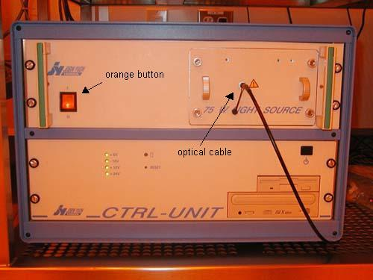
Figure 1. Control unit. The light travels through the optical cable to the sample stage.

- Enter the Windows password.
- Open the "DeltaPsi2" software.
- Click on the "software options" tab (the fourth button from the left on the top tool bar).

Figure 2. “Software options” tab.

- On the left-hand selection menu, choose "User Library".

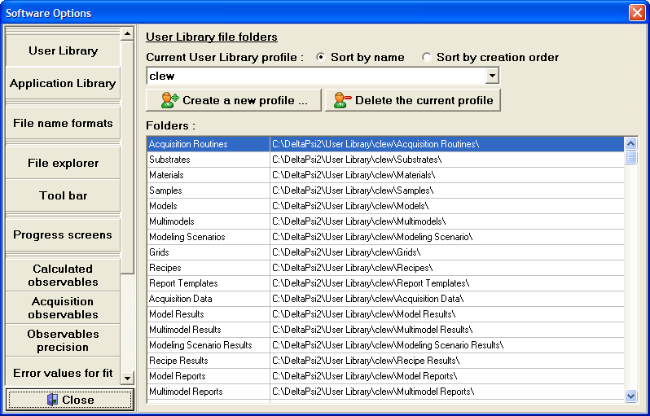
Figure 3. “Software Options” window.

- On the right-hand screen, choose your user library profile in the drop-down menu or click “Create a new profile…”.
- Close the "software options" window.
- Click the "manual measurement" tab (the fifth button from the left on the top tool bar). This will open the "Views" screen.

Figure 4. “Manual measurement” tab.

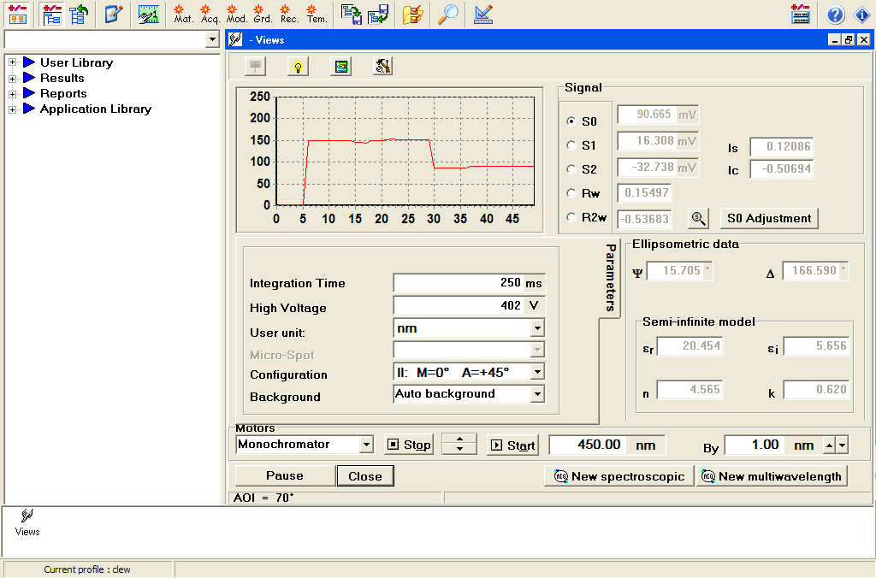
Figure 5. Views screen.

- Toward the bottom of the window, just above the "New spectroscopic" button, enter "450" as the wavelength. Press Enter. Click the "Start" button just to the left of where you entered 450.
- Place your sample on the stage and locate the sample spot by placing a piece of weighing paper over the sample. Once you have positioned the spot where you want to take your measurement, remove the weighing paper. Turn on the vacuum.

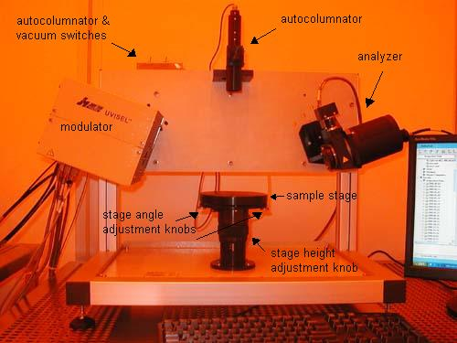
Figure 6. Ellipsometer.

- Adjust the height of the stage by turning the height adjustment knob underneath the stage. Turn the knob back and forth until the S0 reaches a maximum.
- Turn on the autocolumnator light.
- Look through the autocolumnator and align the crosshairs so the centers overlap by turning the two silver knobs underneath the stage. This process assures that the sample is perpendicular to the autocolumnator.
- On the "Views" screen, click "S0 Adjustment" or manually change the high voltage so the S0 is between 80-100 mV.
- As for the rest of the parameters, Figure 5 shows the most common settings. You may change them if they are appropriate for your sample.
- Click "New spectroscopic".
- You will now see the "Acquisition Routine" window. Again, Figure 7 shows the most common merge settings, but you may change them as necessary.

  - If you use No merge, your results will be based on one measurement. Your samples should be based on Δ and I_{c}.
  - If you use Standard merge, two measurements will be taken, and the software will average the two to eliminate noise. Your samples should be based on I_{s} and I_{c}. Standard merge is the default setting.

$$\begin{aligned}I_{s}=\text{sin}2Ψ\text{sin}Δ \\ I_{c}=\text{sin}2Ψ\text{cos}Δ \\ Δ={\text{tan}}^{−1}\frac{I_{s}}{I_{c}}\end{aligned}$$

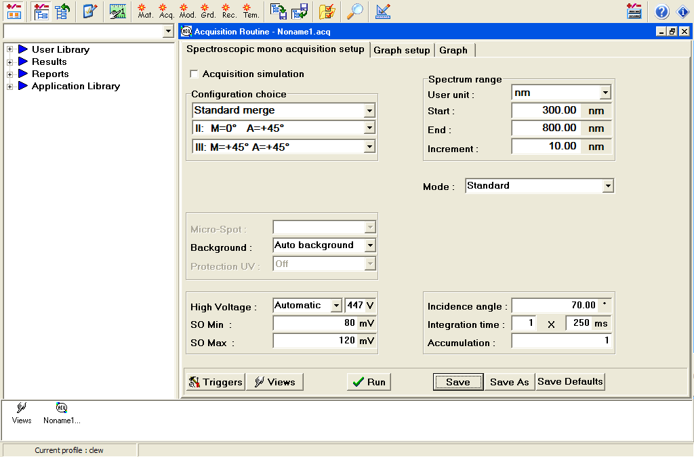
Figure 7. Acquisition routine screen before sample run.

The spectrum range will depend on your sample.

- Click "Run". A window will pop-up and say that "Views will be closed". Click "Ok".
- Enter your sample name and any comments you need. Click "Ok".
- The ellipsometer will then run your sample and you will see a window with various spectra:

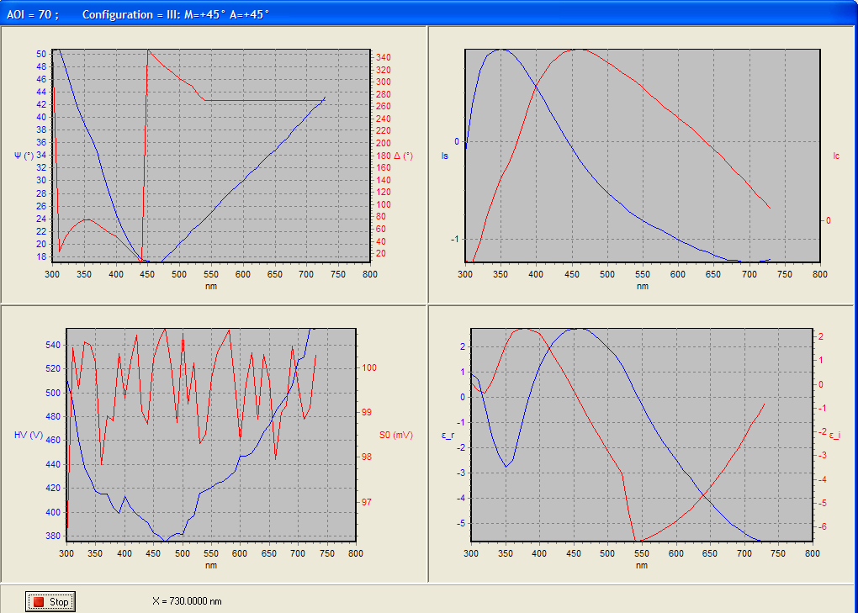
Figure 8. Spectra during sample run.

- When the sample is finished, the spectra window will disappear and you will see the acquisition routine window:

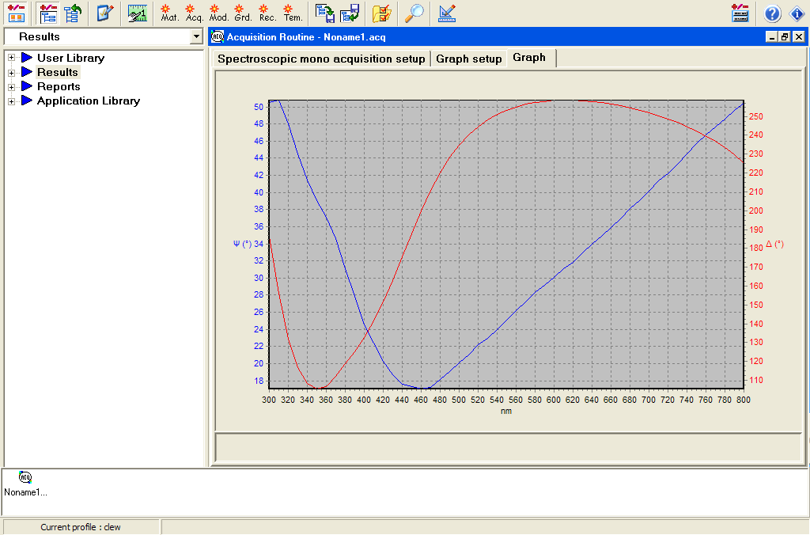
Figure 9. Acquisition routine after sample run.

- You now need to fit your model to the data.

Model Fitting
- Click on "Create a new model..." tab (the eighth button from the left on the top tool bar). Make sure "User Library" is selected and then click on the "Model" button.

Figure 10. “Create a new model…” tab.

- First, build a model of your substrate and your material. The purple bar is your substrate. If your substrate is a popular material (e.g., crystalline silicon, alumina, etc.), you can probably find it in the software library of materials. In the left-hand selection menu, expand "Application Library" --> "Materials". Find your substrate material and drag it to the purple bar on the right. If your substrate is a mixture of two or more materials, you may drag other materials into the same purple bar. Try to define the percent composition as close as possible (50% and 50% is the default composition for a two-material model).

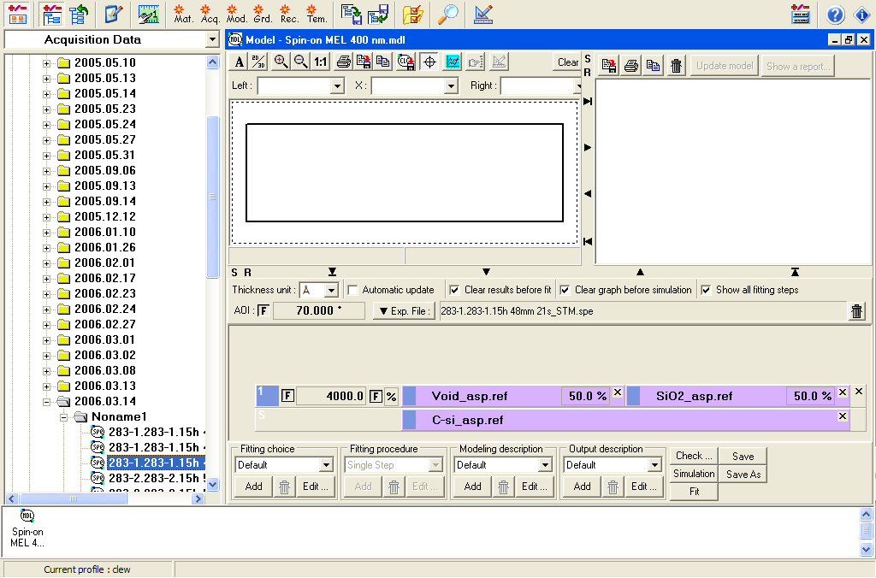
Figure 11. Model window.

- Now you need to build your sample material. Choose another material from the "Materials" menu and drag it anywhere in the gray area above the purple substrate. There will now be a second purple bar with the first layer of your sample. Again, you can add more materials to this first layer and define the percent composition. You can also add more layers by dragging more materials from the menu on the left to the gray area above your sample model.
- To the left of the purple bars, each layer will be defined starting with the substrate ("S"), your first layer ("1"), second layer ("2"), and so on. A default thickness of 1000 Å will be given for each layer as an initial guess. You can change this by clicking on the "1000” to the left of the purple bar. You can try an initial nominal value or a range of values (“Multiguess”). Keep in mind that for the Multiguess function, the larger the range and the smaller the increment, the longer the model calculation will take. To fit the model to the data, check the box to the left of the thickness, and an “F” will appear. If your layer contains more than one material, click the box to the right of the thickness to fit the percent composition as well.
- If your substrate and/or your layer(s) are porous, you can add “Void_asp.ref” from the “Materials” on the left. In the model, void space is treated like a chemical material.
- If you want to create your own material, click the “Mat” tab (the sixth button from the left on the top tool bar).
- Next, you need to add your data to the model. In the left-hand selection menu, expand “Results” --> “Acquisition Data” --> “(date)” --> “NonameX”. Choose the run that you want to model. If you used the Standard Merge, use the file that ends in “_STM.spe”. Drag your run to the gray bar that is above your model and to the left of the trash can.
- The angle of incidence of the light (the angle between the analyzer and your sample, as well as the modulator and your sample) should be 70 degrees but your run will not be exactly 70 degrees. If you want to see how close your run was to 70 degrees, check the box to the right of “AOI”.
- Under “Modeling description” toward the bottom of the screen, click “Edit...”. Under the “Modeling conditions” tab, you will probably want to select “Experimental file spectral range”. This will fit your model to the spectral range that you defined in the initial “Acquisition Routine” window before your run. However, if you want to use a smaller range, you can use a “User defined spectral range”. Click “Ok”.
- Click “Fit”. You will now see a window that shows the parameters that you wanted to find. If the fit (Χ²) is not good enough, you can close this window and modify your model.

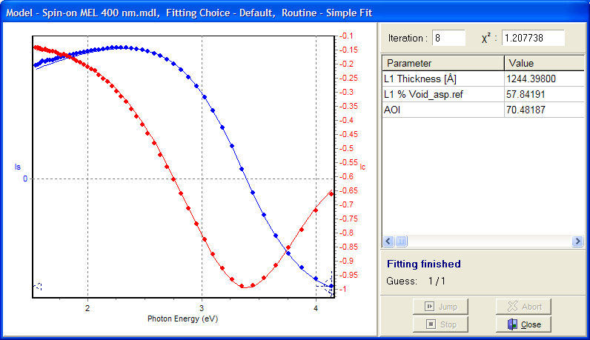
Figure 12. Modeling results.

- You may save your model for future use by clicking “Save”. You can later find this model in the left-hand selection menu under “User Library” --> “Models”. Double-click on your model to open it.
- When you are finished modeling your data, close the modeling window. Close both the “Jobin Yvon / Horiba” and the “Ellipsometric Server” windows. (Your data will automatically be saved.) Turn off the autocolumnator light and the vacuum. Remove your sample. Turn off the xenon arc lamp. Log-off the computer and sign the log book.

