N
E

Oxford Cobra Silicon Trench Etcher
Operation Procedure

1.0 SCOPE
This document establishes the procedures for operating the Oxford Silicon Trench Etching system inside the MSE cleanroom. There is no additional charge to use this tool, standard cleanroom fees apply the entire time that the tool is occupied. Online reservations are mandatory.

2.0 APPLICABLE DOCUMENTS
This Manual

3.0 MATERIALS AND EQUIPMENT
Face Mask
Tweezers
4” silicon support wafer (see important notes)
Nitrile Gloves
Wafer attachment material (see important notes)

4.0 GENERAL
Tool Overview
The Oxford Cobra Silicon Trench Etcher is a fluorine-based Inductively Coupled Plasma (ICP) etch tool that provides capability for highly anisotropic dry etching of Si and SiO2 with high mask selectivity. The standard baseline etch processes for this tool include:

- SiO2 Etch: Low temperature (-20°C) C4F8-based process for anisotropic etching of SiO2 with ~170 nm/min etch rate, ~2:1 SiO2:PR selectivity, and >85° sidewall profile.*

- Si DRIE: Room temperature (+20°C) SF6/C4F8-based cyclic etch/passivation process for highly anisotropic deep etching of Si with ~4 µm/min etch rate, >75:1 Si:PR & Si:SiO2 selectivity, and ~90° sidewall profile.*
  - The cyclic nature of this process results in sidewall scalloping with depth up to a few hundred nanometers. Those requiring smoother sidewalls should consider using the CRYO Si DRIE process.

- CRYO Si DRIE: Cryogenic (-120°C) SF6/O2-based non-cyclic process for highly anisotropic deep etching of Si with >2 µm/min etch rate, >75:1 Si:PR & 150:1 Si:SiO2 selectivity, and ~90° sidewall profile.*
  - The non-cyclic nature of this process results in smooth sidewalls. However, the relatively low etch rate makes this process better suited to shallower etches of fine features.
  - To minimize potential for cracking, PR mask thickness must be <1.3 µm.

*These etch performance parameters are only meant to serve as a general guide. Actual performance will depend heavily on pattern geometry, exposed area, substrate size, etc.

Tool: Silicon Trench Etcher
4.1

IMPORTANT NOTES:

- Users must complete tool training with the Cleanroom personnel AND undergo two supervised sessions with designated tool Superusers before they are granted access to the tool. A list of current Superusers is posted on the tool.

- Users are only permitted to run the standard baseline etch processes for this tool (i.e. SiO2 Etch, Si DRIE, & Cryo Si DRIE). Users interested in running other processes must first seek approval from Prof. Masaru Rao (mprao@engr.ucr.edu).

- Users must run appropriate chamber clean & conditioning processes before their etch, as well as an appropriate chamber clean process after their etch. These processes are to be run using 100mm Si Clean/Condition Wafers provided by the cleanroom. Do not use your Device Wafers for these processes.

- Users intending to run cryogenic etch processes (i.e., Lower Electrode <0 °C) must notify the Cleanroom personnel at least 24 hrs in advance of their reservation, so they have sufficient time to reconfigure the tool.

- Recipes #1-12 are the standard baseline processes for this tool (see Appendices for process conditions for all Baseline processes). Users may only modify the run times in these recipes; no other process conditions may be altered without permission.

- The tool is configured with a mechanical clamp for use with 100mm Si wafers. Users working with chip-scale substrates must affix their substrates to a 100mm Si Carrier Wafer using one of the following methods: 1) Santovac oil; 2) Fomblin oil; 3) 3M Thermally Conductive double-sided adhesive tape; or 4) Photoresist. NO OTHER FIXATION METHODS ARE ALLOWED. For all approved fixation methods (except PR), users must ensure that the fixative agent is not directly exposed to the plasma.

- Users performing wafer-scale etches with thick PR masks (thickness > 3 µm) must perform edge-bead removal to minimize potential for clamp contamination and wafer breakage.

- Users performing long and/or through-wafer etches must use Si Carrier Wafers with sufficient thickness and/or masking to ensure that the carrier maintains sufficient integrity for the duration of the etch.

- Users performing CRYO Si DRIE etches must use full wafer substrates, since it is difficult to maintain adequate thermal contact between chips and carrier wafers at cryogenic temperatures.

- Users must log their etches in the log book, and clearly document any issues, if they occur (e.g., wafer drop or breakage, robot arm stuck, plasma failure, etc.). Users should also immediately report any issues to the Cleanroom personnel.

- Failure to comply with any of the aforementioned requirements will result in immediate suspension of tool access.

5.0
Tool Operation Overview
Users must run appropriate chamber clean & conditioning processes before their etch, as well as an appropriate chamber clean process after their etch. This is required to minimize chamber contamination, and thus, ensure greater etch reproducibility, as well as increased time between mechanical chamber cleans. The specific sequence of processes is as follows:

- Pre-etch Chamber Clean: Short duration recipes that remove residual contamination from chamber walls (process is run using a Si Clean/Condition Wafer).
- Pre-etch Chamber Condition: Short duration recipes that coat chamber walls with species specific to your etch to ensure greater reproducibility (process is run using a Si Clean/Condition Wafer).
- Wafer Load: Procedure to open the load lock to remove the Si Clean/Condition Wafer and load your Device Wafer for etching.
- User Etch: Your specific etch process.
- Wafer Unload: Procedure to remove your Device Wafer from the load lock after etching and insert a Si Clean/Condition Wafer for the Post-etch Chamber Clean.
- Post-etch Chamber Clean: Recipes that remove contamination from chamber walls. The duration of the recipe should be the same as that of the User Etch, with a 5 minute minimum (process is run using a Si Clean/Condition Wafer).

Failure to comply with pre- and post-etch condition/clean procedures will result in immediate suspension of tool access.

6.0
Detailed Tool Operation Instructions

  - Pre-etch Chamber Clean

REMINDER: This process is run using a Si Clean/Condition Wafer, not your Device Wafer.

  - The system should be in the “System Pumping Screen.”
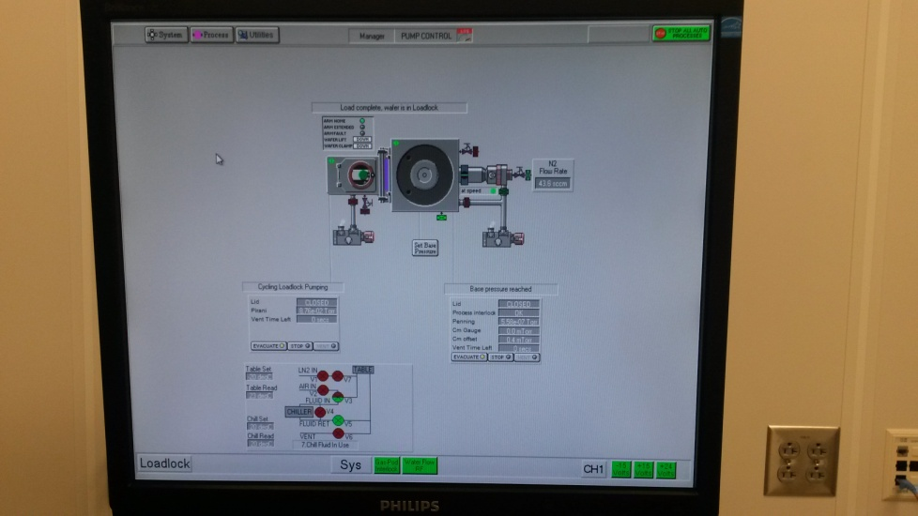

6.1 Look through the load lock window to confirm the presence of a clean and correctly positioned Si
Clean/Condition Wafer on the robotic arm. Also confirm that the load lock is under vacuum.
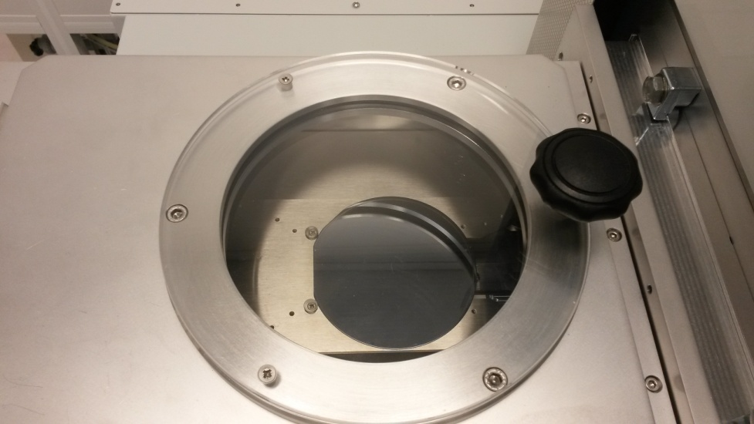

  - Press Process in the top left to drop down the “Process Menu” and then click on Recipes.
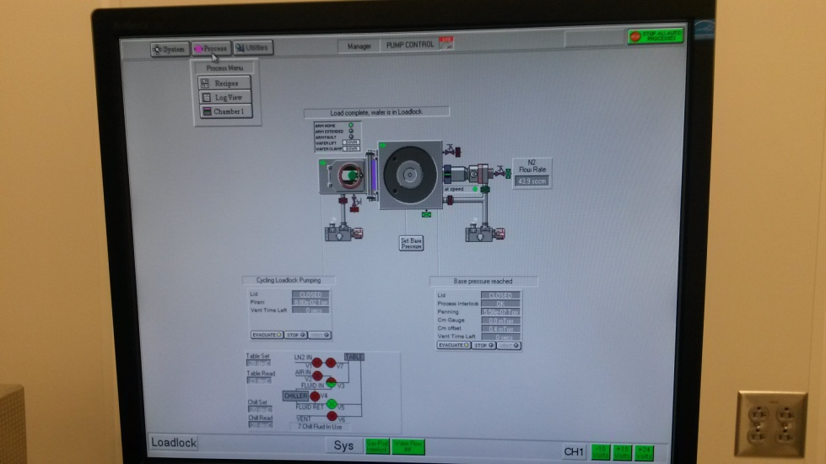

  - On the “Recipes” page, press Load and it will prompt you about overwriting the current Recipe.
Press Yes.
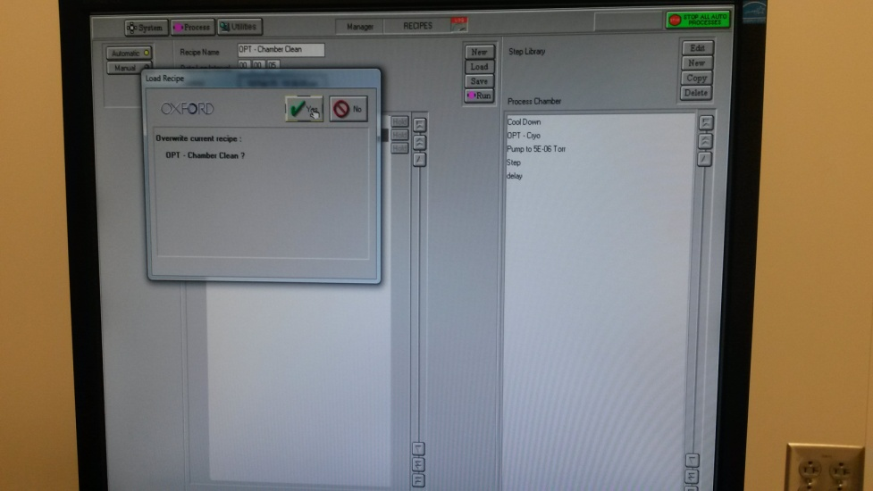

  - Select the appropriate chamber cleaning recipe for your intended etch process, and then press
OK.
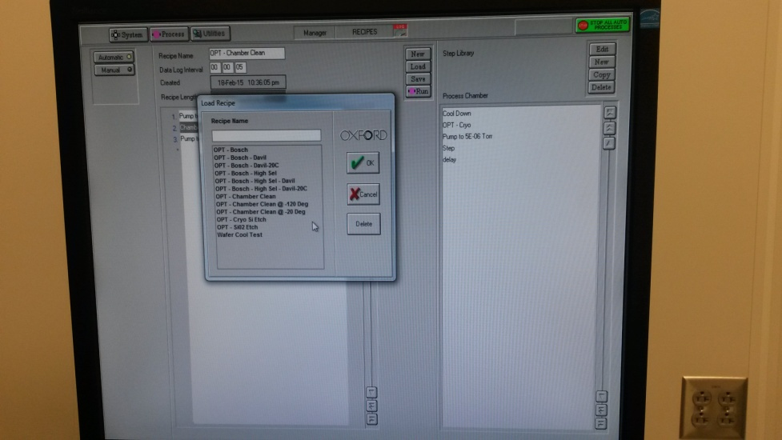

  - Left click on Chamber Clean to bring up a drop down menu.
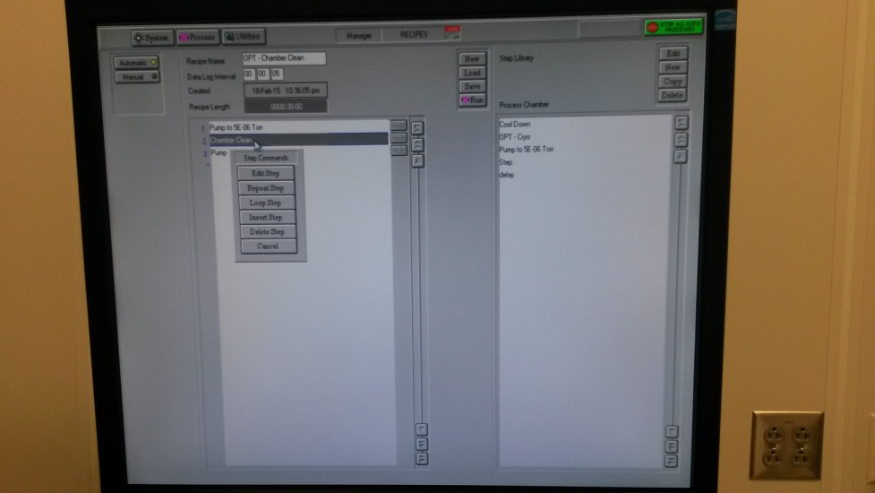

  - Press Edit Step to bring up the parameter screen.
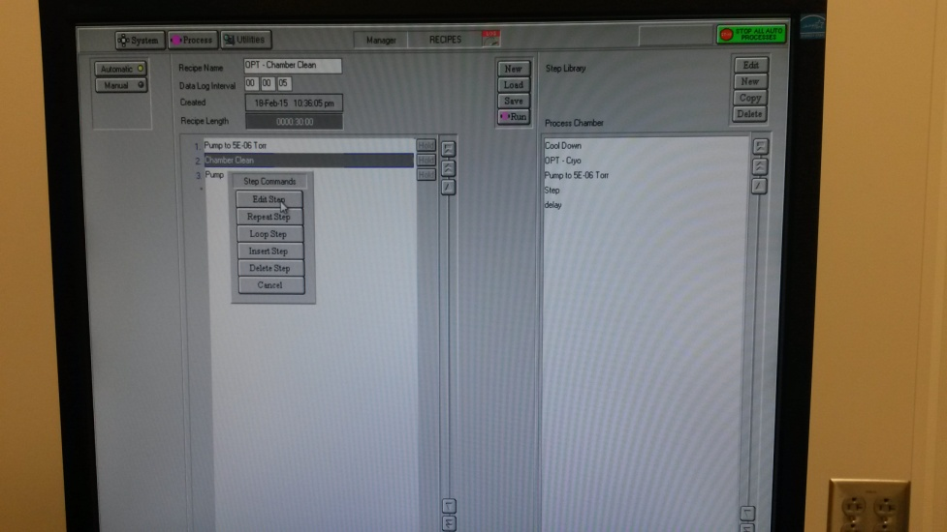

  - Set the “Step Time” (if necessary) to 10 minutes. DO NOT CHANGE THE OTHER
PARAMETERS!
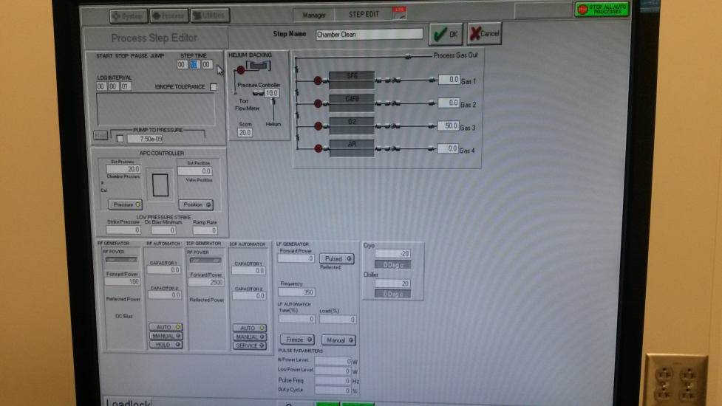

  - Press OK to return to the previous screen.
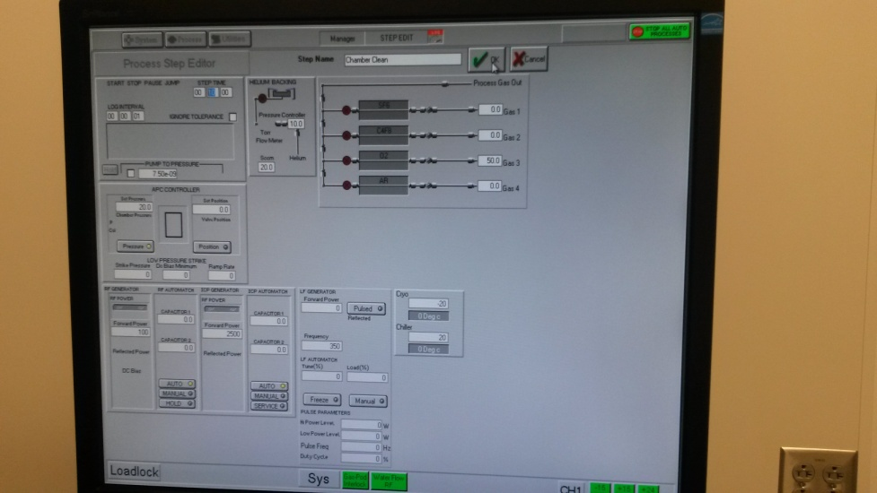

  - Press Run to run the Pre-etch Chamber Clean.
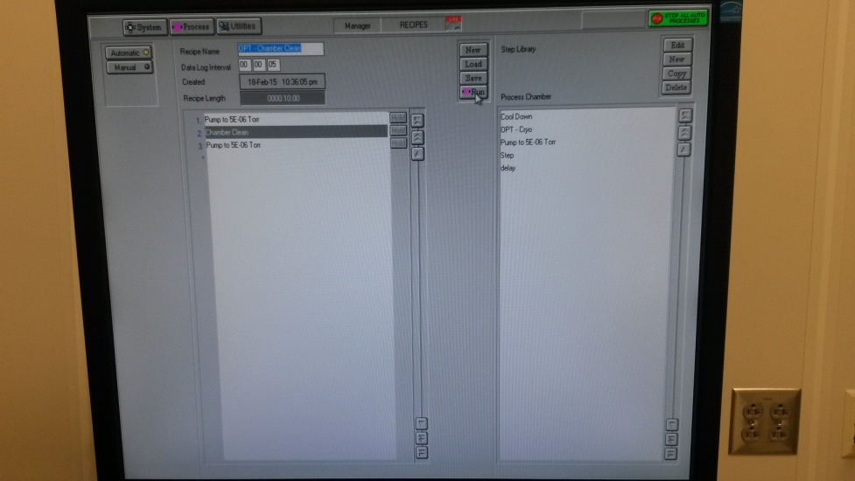

  - If it prompts you about running another process on the wafer in the Loadlock, press Yes.
The wafer should transfer into the chamber and the plasma should initiate.

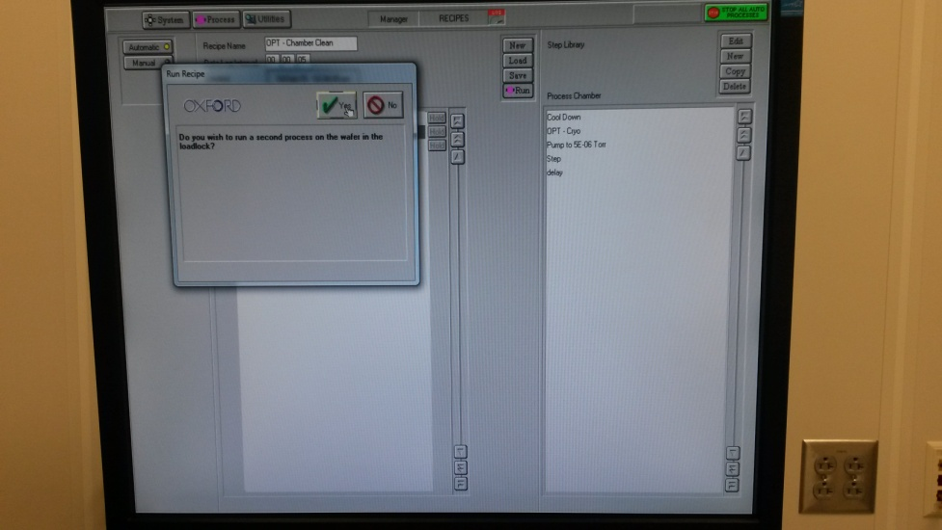

  - When this process is complete, the wafer should transfer back into the load lock and a yellow
Alert will pop up. Click Accept.
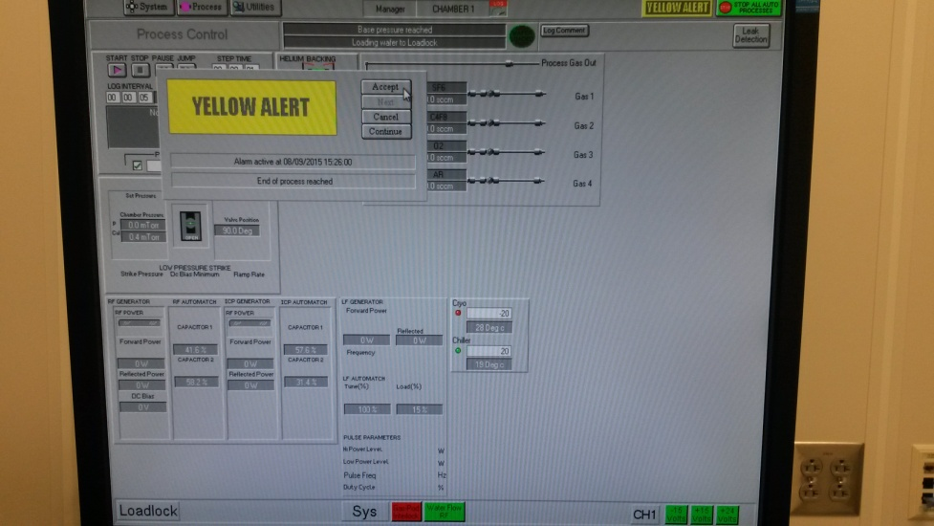

  - After a while, the screen should return to the “System Pumping Screen” and prompt you that the
Process Completed OK. Press OK. You may now move on to the Chamber Conditioning step.
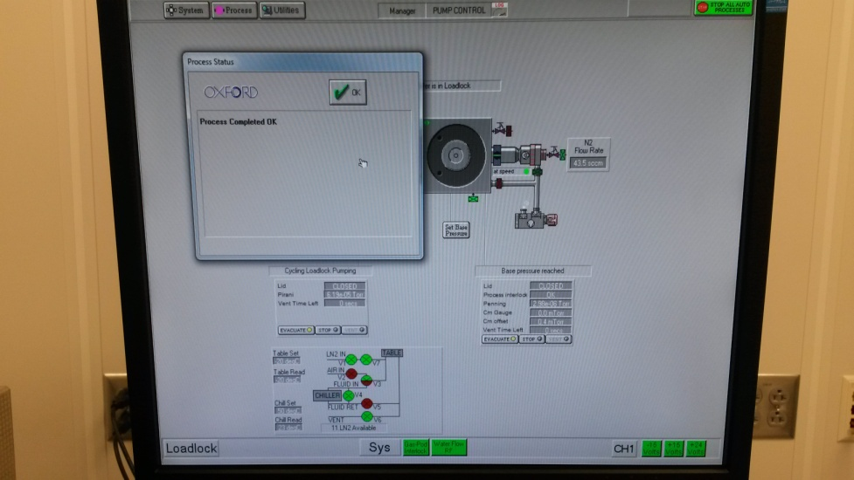

- Pre-etch Chamber Condition

REMINDER: This process is run using a Si Clean/Condition Wafer, not your Device Wafer.

  - The system should be in the “System Pumping Screen.” Press Process in the top left to drop
down the “Process Menu” and then click on Recipes.

  - On the “Recipes” page, press Load and it will prompt you about overwriting the current Recipe.
Press Yes.

  - Select the appropriate chamber conditioning recipe for your intended etch process, and
then press OK.
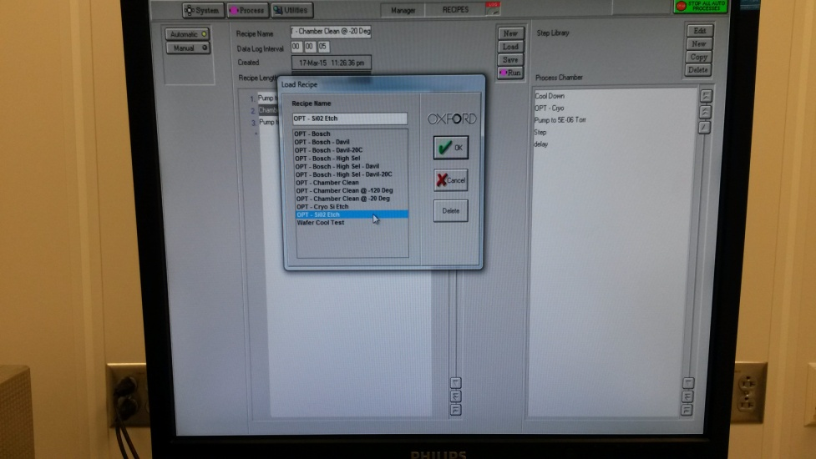

  - Left click on the Etch Step to bring up a drop down menu. Press Edit Step to bring up the
parameter screen
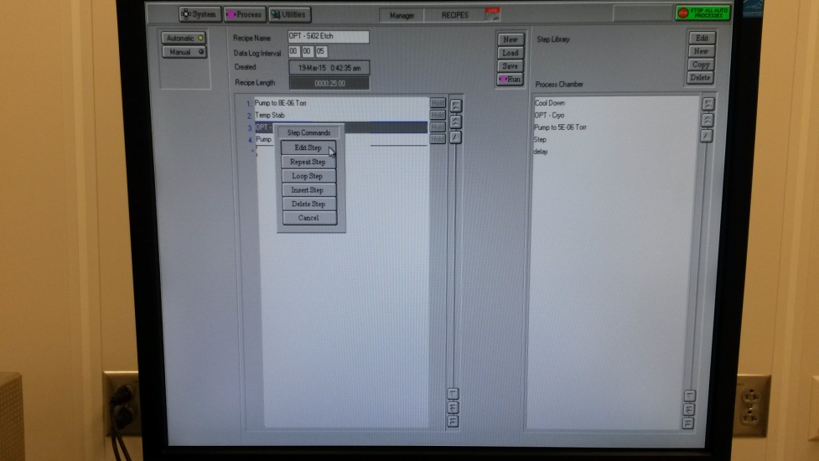

  - Set the “Step Time” (if necessary) to 10 minutes. DO NOT CHANGE THE OTHER
PARAMETERS!
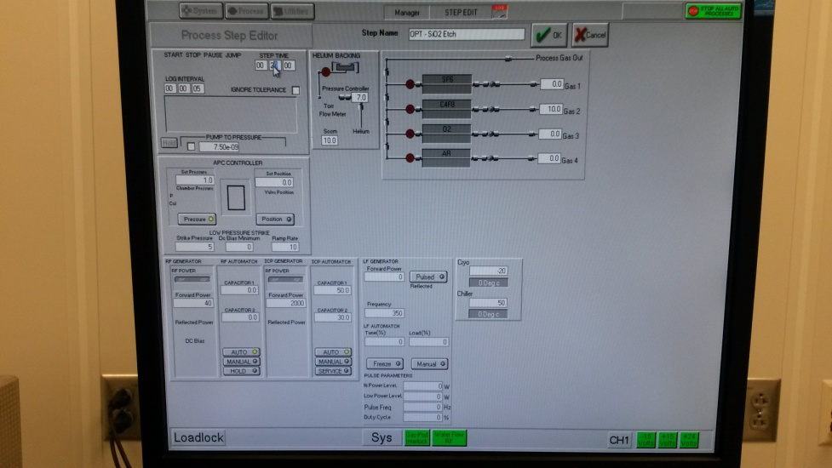

  - Press OK to return to the previous screen.
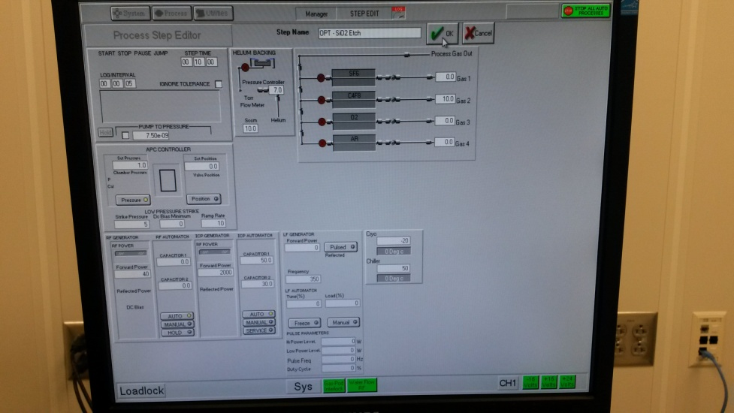

  - Press Process in the top left corner and then click on Chamber 1.
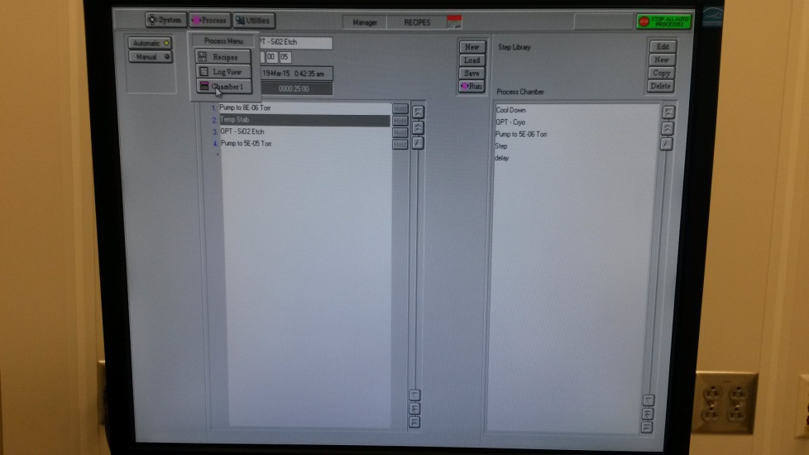

  - Wait for the tool to reach the set temperature.
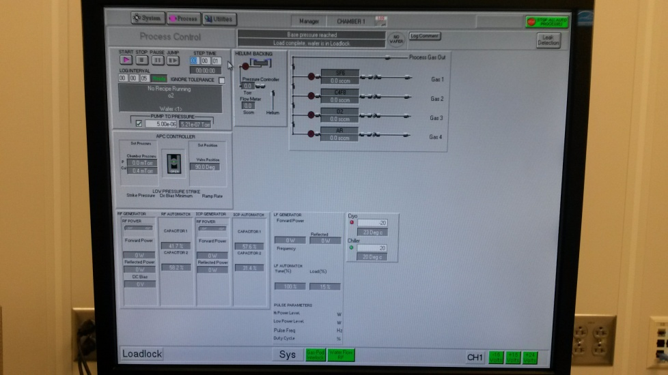

  - Once the tool has reached the proper temperature, press Process in the top left to drop down the “Process Menu” and then click on Recipes to return to the “Recipes” page.
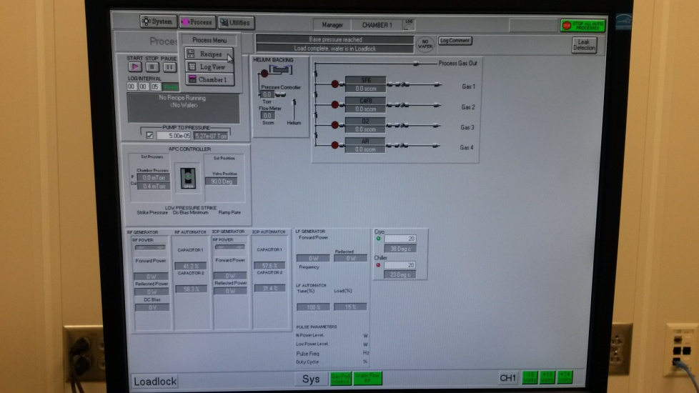

  - Press Run to run the Chamber Condition.
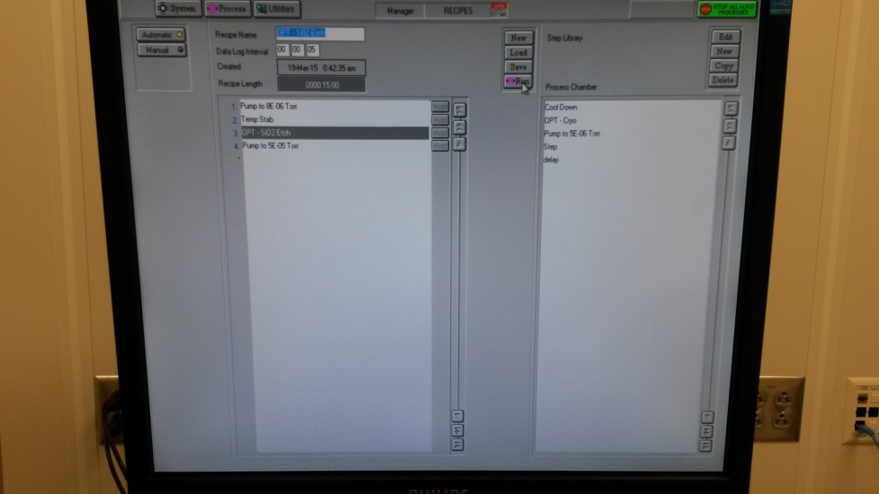

  - If it prompts you about running another process on the wafer in the load lock, press Yes. The wafer should transfer into the chamber and the plasma should initiate.
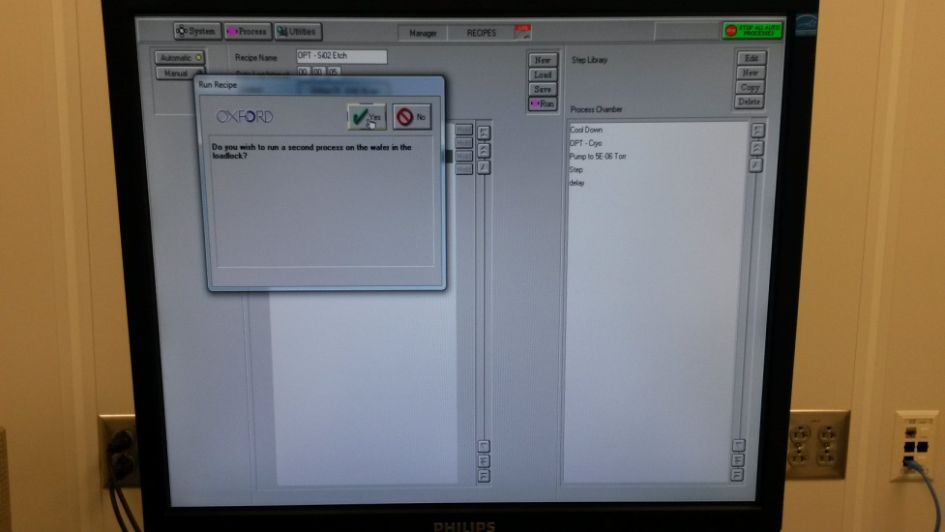

  - When this process is complete, the wafer should transfer back into the load lock and a yellow alert will pop up. Click Accept.

  - After a short while, it should return the screen to the “System Pumping Screen” and prompt you that the Process Completed OK. Press OK. You may now move on to the Wafer Load step.

8.0 Wafer Load

REMINDER: This process is used for unloading the Si Clean/Condition Wafer, and then loading your Device Wafer.

8.1 The load lock must be vented before opening.

8.2 The system should be in the “System Pumping Screen.”
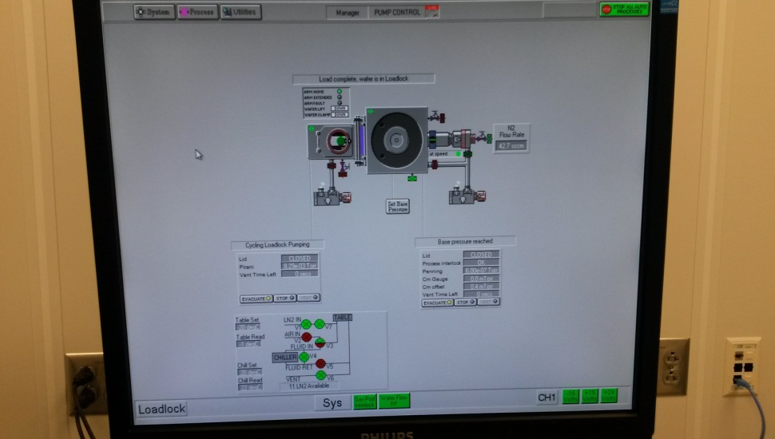

8.3 Press the button that says STOP under “Cycling Loadlock Pumping.”
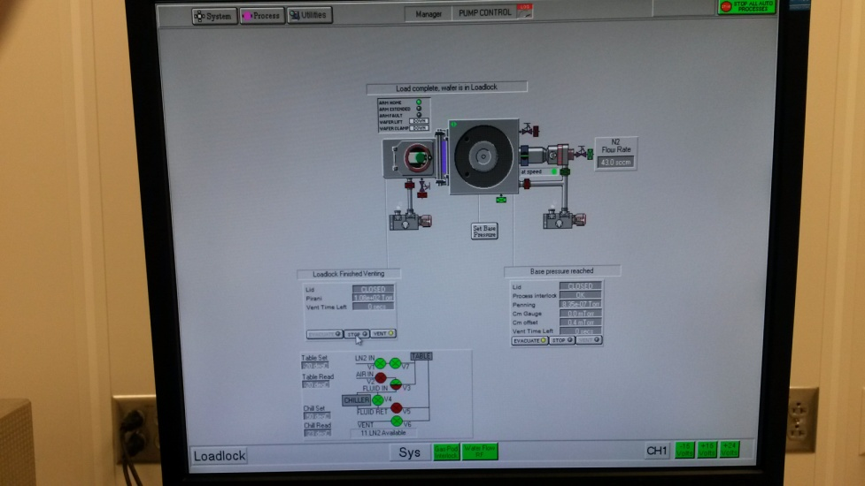

  - Wait a few seconds, and then press the button that says VENT under “Cycling Loadlock Pumping”.
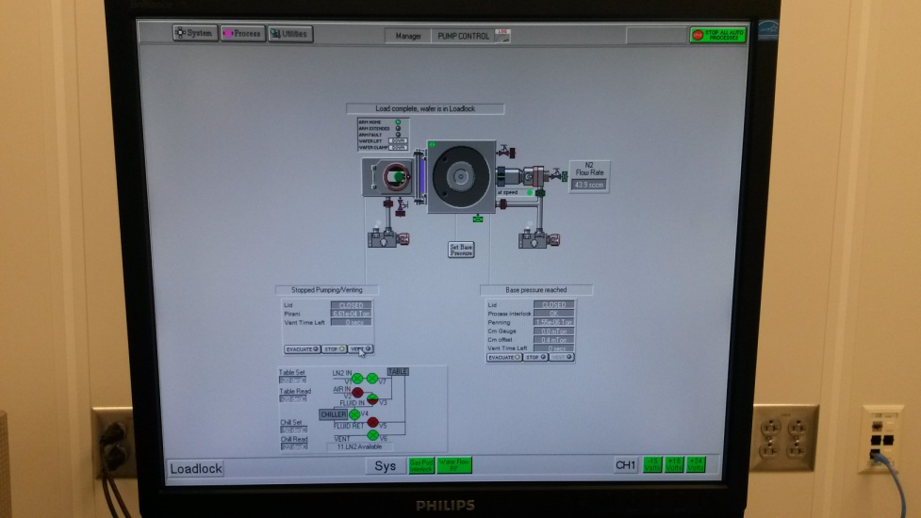

  - Wait until the “Vent Time Left” is under 90 seconds. You may then open the load lock by pulling up on the knob. Do not open before this time, or you may damage the tool!

  - Remove the Si Clean/Condition Wafer from the load lock, and then place your Device Wafer. Make sure to align it so that the flat is positioned in the middle between the two pins!
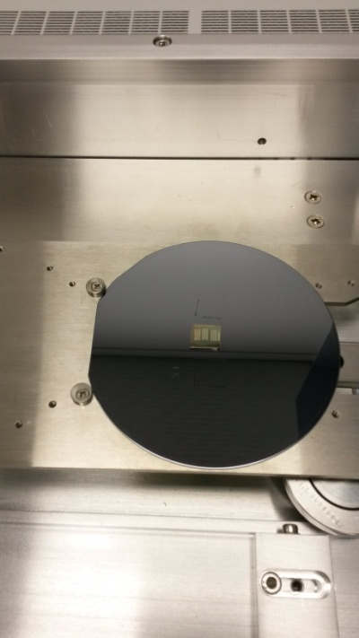

  - Lower the load lock door and make sure it is fully closed. Then press the STOP button under “Cycling Loadlock Pumping.”

  - Wait a few seconds and then press the EVACUATE button under “Cycling Loadlock Pumping.”
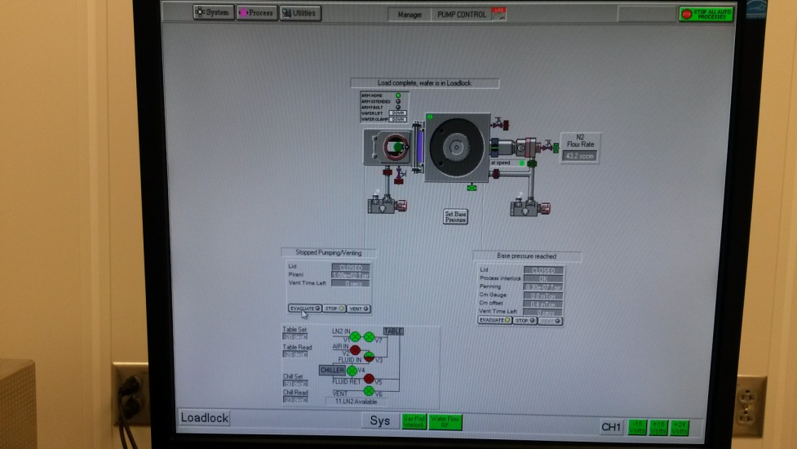

  - The tool will prompt you to enter a name for the wafer. Type a name for the wafer process and press OK.
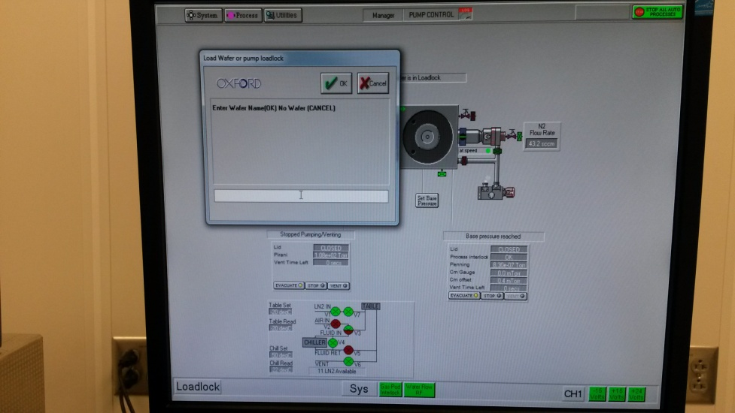

  - Once the load lock is pumped, you may move onto the User Etch step.

9.0 User Etch

9.1 The system should be in the “System Pumping Screen.” Press Process in the top left to drop down the “Process Menu” and then click on Recipes.

  - On the “Recipes” page, press Load and it should prompt you about overwriting the current Recipe. Press Yes.

  - Select the etch that you want to run and then press OK.

9.4 Left click on the etch step to bring up a drop down menu.

  - Press Edit Step to bring up the parameter screen.

  - Set the “Step Time” to your desired etch time. DO NOT CHANGE THE OTHER PARAMETERS!

  - Press OK to return to the previous screen.

  - Press Run to begin the etch on your sample. The wafer should transfer into the chamber and the plasma should initiate.

  - When this process is complete, the wafer should transfer back into the load lock and a yellow
alert will pop up. Click Accept.

  - This should return the screen to the “System Pumping Screen,” where you will be prompted with Process Completed OK. Press OK. You may now move on to the Wafer Unload step.

10.0 Wafer Unload

REMINDER: This process is used for unloading your Device Wafer, and then loading the Si Clean/Condition Wafer.

  - The system should be in the “System Pumping Screen.”

10.2 Press the button that says STOP under “Cycling Loadlock Pumping.”

  - Wait a few seconds, and then press the button that says VENT under “Cycling Loadlock Pumping.”

  - Wait until the “Vent Time Left” is under 90 seconds, you may then open the load lock by pulling
up on the knob. Do not open before this time, or you may damage the tool!

  - Remove your Device Wafer from the load lock, and then place a Si Clean/Condition Wafer. Make sure to align it so that the flat is positioned in the middle between the two pins!

  - Close the load lock door and make sure it is fully closed. Then press the STOP button under “Cycling Loadlock Pumping.”

  - Wait a few seconds and then press the EVACUATE button under “Cycling Loadlock Pumping.”

  - The tool will then prompt you to enter a name for the wafer. Type a name and press OK.

  - Once the load lock is pumped, you may move onto the Post-Etch Chamber Clean step.

- Post-etch Chamber Clean

REMINDER: This process is run using a Si Clean/Condition Wafer, not your Device Wafer.

  - The system should be in the “System Pumping Screen.” Press Process in the top left to drop down the “Process Menu” and then click on Recipes.

  - On the “Recipes” page, press Load and it should prompt you about overwriting the current Recipe. Press Yes.

  - Select the appropriate chamber clean and then press OK.

  - Left click on “Chamber Clean” to bring up a drop down menu.

  - Press Edit Step to bring up the parameter screen.

  - Set the “Step Time” to the same time you used for the User Etch, or to 5 minutes if the User Etch was less than that. DO NOT CHANGE THE OTHER PARAMETERS!

  - Press OK to return to the previous screen.

  - Press Run to run the Post-Etch Chamber Clean. The wafer should transfer into the chamber and the plasma should initiate.

  - When this process is complete, the wafer should transfer back into the load lock and a yellow alert will pop up. Click Accept.

  - This should return the screen to the “System Pumping Screen,” where you will be prompted with Process Completed OK. Press OK.

  - Fill out the log book

  - Close the valve on the liquid nitrogen tank if necessary

  - Clean up after yourself and make sure everything is put back where it belongs before you leave

