N
E

Center for Nanoscale Science and Engineering

STS DIELECTRIC ETCHING STATION

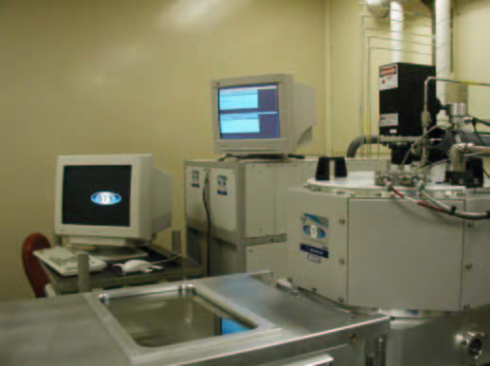

Introduction

STS Reactive Ion Etcher (RIE) dielectric System is designed for isotropic RIE plasma etching of dielectric films. The system is capable deep etching of oxide with high selectivity to resist and silicon and fast etch rates. The RIE plasma etching process is accomplished through the use of a low pressure; 13.56 megahertz radio frequency (RF) induced gaseous discharge.
The specimen is loaded into the reaction chamber and the chamber is evacuated to vacuum pressure of 0.1 - 2.2 torr. A carrier gas is then introduced into the chamber, raising the pressure to 0.3 – 1.2 torr, depending on the application.

RF power is applied around the chamber. This excites the carrier gas molecules and dissociates it into chemically active atoms and molecules. The chemically active ions are accelerated along electric field lines to meet a substrate perpendicular to its surface. The mechanism employed in this process is one of ionization. The combustion products, which are completely dissociated and harmless, are carried away in the gas stream. The process occurs at relatively low temperature without employing toxic chemicals.

General

The system is set to handle four different gases (CF4, CHF3, O2, and He) for etching of Silicon Nitride or Silicon Dioxide at various etch rates. The sample is backside cooled during etch processes. The system is equipped with two chambers for high thru – put and reproducibility. The first chamber is a Load Lock chamber used for wafer transferring and a main chamber used for stable process under vacuum at all times.

Note:
- For safety, locate red emergency off button in front of tool for immediate shutdown.
- Wear gloves when using vacuum system at all times.
- Don’t operate system in unsafe manor.
- All materials should be approved before use in the system.
- For vacuum definitions and terms go to glossary.

Operation Procedures

- STS Overview
The station has a load lock chamber, main chamber, 4 mass flow controllers in the gas manifold box, instrument control rack, 600 watt RF power supply and a PC enter phase control. The system is capable of handling 2 four inch wafers at a time.

The station is designed to etch Silicon dioxide dielectric films etch in CHF3 gas process and Silicon Nitride dielectric films in CF4 at fast etch rates.

- Wafer Loading
  - Wafer load procedures
2.1.1 Go to PC control screen and locate mouse.
    - Go to “Vent” in the Transfer Editor with the arrow.
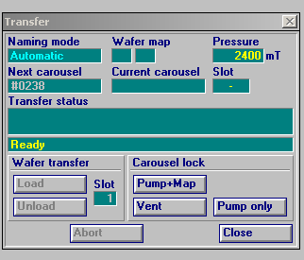
Fig.1 Transfer Editor

    - Click on “Vent”, the chamber will vent after 3 purge cycles and Load Lock chamber will open at 760 Torr. Caution Chamber pops up!!
    - Load wafer in slot 1 on Carousel; if two wafers load in slot 1 and 2.
    - Latch the Load Lock handle on Load Lock chamber.
    - Click on “Pump and Map” on transfer Editor. Load Lock chamber will pump down and map wafer carousel.
    - Click on “Load”, Carousel will load sample in main chamber and pump down.

- Recipe Selection
  - Recipe load procedures
    - Go to Process control Editor Click on “select”.
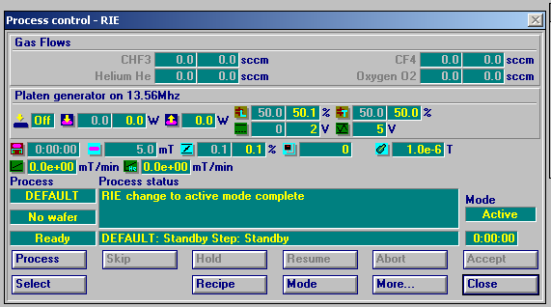
Fig.2 Process control editor

    - The Run RIE Process editor will appear with all the available files.
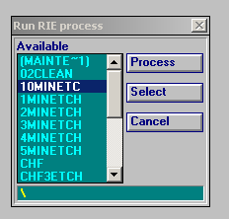
Fig. 3 Run RIE process editor

    - Click on “select” to select the desired process recipe from the Run RIE process editor.
Fig.4 Process control editor

    - Now click on “Process” in the process control editor to run the recipe.
    - To view or edit recipe go 5.0 before starting.

- Wafer unload
  - Wafer unload procedures
    - Go to Transfer Editor and click on “unload”.
Fig.5 Transfer Editor

    - Click on “vent” after carousel returns to load lock chamber. The system will cycle purge before opening.
    - Wait for the system to reach atmosphere and unload wafer.
    - Close and latch load lock chamber.
    - Click on “Pump only” this is the standby state and the process is complete.

- View or Edit Recipes
  - Editing Recipes procedures
    - Click on “Recipe” in the Process control – RIE editor.
Fig.6 Process control editor

    - Then the recipe editor will appear.
    - Click on “open” file
    - Then select file recipe and Click “o.k.”
    - Then Click on recipe file in the description column.
    - Now you are in the recipe editor.
    - Select parameter and change settings. Do not change program parameters. Change time or power only. If your research requires a special specific recipe, contact lab staff.
    - Now go back to 3.0 to run process.

____________________________________________________________________________________________________________________________________________

Glossary of Terms

Atmosphere – 760 torr

Back streaming - at a vacuum equilibrium mechanical pump oil can be transferred from the mechanical pump to the chamber.

Base pressure - the ultimate pump pressure; ultimate pump pressure and the sum of each independent gas flow in the foreline.

Capacitance manometer - a diaphragm gauge in which the deflection of the diaphragm is measured by observing the change in capacitance between it and fixed counter electrode.

Cryogenic pump - the entrainment of molecules on a cooled surface; a surface array is cooled low enough so that of arriving molecules will remain on the surface of the array after losing sufficient kinetic energy.

Diffusion pump - is a vapor jet pump which transports gas by momentum transfer on collision with vapor stream.

Gate valve – a high pressure pneumatic solenoid valve that separates two chambers in a vacuum systems.

High vacuum - at a pressure of 10 x -4 Pa to 7.5 x 10 -7 Torr; rubber o rings are used.

Mean free path - is the mean free path of a molecule of particle, is the average distance the particle travels between collisions with other particles.

Mechanical pump - typically a rotary vane pump, gas enters the suction chamber and is compressed by the rotor and the vane and expelled to atmosphere through the discharge chamber; pumps of 10 to 200 m3 /h displacement are used for rough pumping and backing diffusion or turbomolecular pumps.

RIE – Reactive Ion Etcher, a plasma reaction vacuum chamber etching tool that use non corrosive and corrosive gas that excite Ions in a plasma etching system.

Thermocouple gauge – a thermal vacuum gauge which reads from atmosphere to 0 mtorr.

Turbomolecular pump – is a bladed molecular turbine that compresses gas by momentum transfer from the high speed rotating blades to the gas the gas molecules. The pump operates at rotor speeds ranging from 24,000 to 60,000 rpm and is driven by solid state power supplies or motor generators.

Ultra high vacuum – 10 x -7 > P to 10 x -10 Torr; metal gaskets are typically used for seals.

Vacuum- a vacuum is a space from which air or other gas has been removed; typically from a chamber.

